Date: February 15, 2018
- Call to Order
Jeff Johnson called the meeting to order at 7:02pm.
- Devotional / Shared Prayer
Joe Zeigler led us in prayer.
- Establish a Quorum
  - Members present: Jeff Johnson, John Shardlow, Mike Dolan, Keith Gilbert, Beth Jacobson,
Jessica Henry, Joe Zeigler, Darci Bontrager, Tom Lund
  - Members absent:
  - Others present: Pastor Lauren Wrightsman, Dave Booms, Laurel Hofeldt, Pastor Sara Spohr, Eric Wolhowe, Dave Richter, Kris Olsen, K J Bach
- Approval of Agenda
A motion to approve the agenda was made by Beth and seconded by Darci. The motion was approved unanimously.
- Approval of January minutes
A motion to approve the January minutes was made by Joe and seconded by Jess. The motion was approved unanimously.
- Mission and Outreach Task Force Recommendations
Dave, Joe, Pastor Sara and Kris outlined their findings. Recommendations included a focus on areas directly relating to our Mission statement, documenting and celebrating activities and resolve to maintain our direction. A motion to accept task force recommendations was made by John and seconded by Joe. Some discussion took place; the proposals received a positive reaction. The motion was approved unanimously. A transition group will be assembled prior to annual meeting, led by Kris.
- Monthly Reports
Staff and committee reports are attached. Any additional discussion is listed below.
  - Finance:
  - Staff
      - Pastors
        - Senior Pastor
        - Associate Pastor
Note Council interviews with 9th graders on March 15th.

      - Church Administrator
E blast will receive a revamp. Signage changes will be needed inside and outside buildings. Some boiler circulation pumps were replaced. Upgrade on a/v, sound in worship center, projectors, flat screens will be addressed. Need for help for soup supper.
  - Committee Reports
    - Mission & Outreach- Darci
    - Stewardship- Keith
    - Children- Joe
    - Youth & Family- Jessie
    - Adult Ed- Beth
    - Christian Life- Beth
    - Nominating- Mike Tom

- Strategic Planning
      - Facilities and maintenance task force

- Items for Discussion
      - Council liaison report format
The report format was accepted and will be used for future reports.

- New Business (Action Items)
- Upcoming dates
- Adjournment
A motion to adjourn was made by Jess and seconded by Beth. The motion was approved unanimously.
- Closing Prayer
Pastor Lauren led Council in the Lord’s Prayer.

Respectfully submitted,
Mike Dolan
Council Vice President
Roseville Lutheran Church

Council Report
Senior Pastor, Lauren Wrightsman
February 15, 2018

- Action Items in Progress / Pending

Constitution / Bylaws review
In have reached out to the St. Paul Area Synod for information on our constitution and bylaws review. With the work of committees and teams redefining their charters it is apparent that this is a needed and necessary step. I will bring more information on the process at subsequent council meetings. I will be needing people to partner with on this project. Please send me any names of people who may be interested.

75 hours of Giving
A dedicated group of lay leaders and staff are directing an “end of year giving campaign.” This will begin on Sunday, April 22nd and go through the afternoon on Wednesday, April 25th. This will largely be an online “Give 2 the Max” style campaign.
President Jeff Johnson is also on this campaign team.

Council / Congregation Awareness
Starting this month, we will be sending out a notice to all council members as to when they will be worshipping that weekend. Pastors will announce at services that council members will be at the Welcome Desk to answer any questions. We appreciate your willingness to do this. Please wear your nametag on Sundays.

- Action Items Completed

Wedding Policy
Our policies have been clarified and the document is now complete
Personnel Policy Manual
Completed and in the hands of the Executive committee for review
Innovations in Management
All sessions have been completed. Staff is utilizing many of the suggestions given and are encouraged by the team sessions we have had. Thank you for being a partner in the lay leadership sessions. I would like to know your thoughts on the event.

- Budget Requirements (if any)
none

- Questions for the council to address. Do any require council vote? (Yes or No)

- Other comments

Council Report

Staff Member name: Pastor Sara Spohr

Date: February 2018

- Action Items in Progress / Pending

- Mission and Outreach Taskforce. The report of the Mission and Outreach Task Force is a part of your council report this month. Please take time to read this document, members of our team will present a report at our February meeting. We are excited about the work and the plans we have to bring it to life in our congregation. We will welcome your questions.

- Lent - Our Lenten devotional is ready to go. By the time we meet you should have received your first two devotions in your email. We also are starting a Lenten Mentor program with our 9th graders, each student will meet one on one with a caring adult mentor after each Lenten service. We are so thankful to the almost 40 adults who have volunteered their time to mentor our students.

- Our 9th grade students are in the final stretches of their confirmation program, they will soon begin preparing their final papers/projects to represent and share their faith. It is an exciting time. For the past several years we have asked the council to come to the March meeting an hour early so that you can interview these students. Each of you will meet with 2-3 students and engage in a conversation about faith, vocation, and life. We’ll provide you with the questions and you will get a glimpse of what our students are thinking about. Please plan to come at 6:00 pm on March 15 for these interviews. Our back up date is April 19, also at 6:00 pm.

Budget Requirements (if any)

2) Action Items Completed

- The deadline for summer trips has come, and our registrations are coming in well. The boundary water’s trips filled up quickly and we have a waiting list and will perhaps add another trip. This is an exciting time in youth ministry. This week we also have our youth led worship service and the kick off of the youth camp scholarship fundraiser.
- We have already begun engaging in some important conversations with our outreach partnerships, this is something you’ll read about in the Mission and Outreach task force recommendations. We have had some really wonderful conversations with our partners at Bridging, Keystone, Central Park Elementary, and the Roseville Area Angel fund. The goal of these conversations is to hear what our partners need from us (instead of us assuming what they need), to hear success stories that we can share with our congregation, and to dream about what is possible when we partner together. The conversations have been strong, imaginative, and inspiring. I look forward to periodically revisiting these partnerships in the future.
- A story from Keystone. We have contributed to the Roseville Area Angel assistance fund for a couple of years now, the fund has been managed by Keystone. The purpose of this fund is to bridge a gap for people on the brink of homelessness. We recently received this success story from Keystone:

Our Community Social Worker received a referral from an elementary school in Roseville for a single mom of five children ages 8 years to 9 months, who have been facing homelessness since 2012. This mom had recently been approved for a town home, but she was in need of assistance with the damage deposit and first month’s rent in order to move in—the financial gap that is difficult to fund.

We were able to coordinate resources from multiple sources to assist this family with the damage deposit and first month’s rent. The Roseville Angel Fund provided significant assistance with this situation and we would not have seen success with the fund. This family received the best Christmas present they could have asked for: a place to call their own; a newly renovated transitional town house which includes all new flooring, new kitchen cabinetry, counter tops, washer and dryer, painting throughout plus plumbing and maintenance repairs and a playground on site for the children to play, furniture and beds, and pajamas and small gifts for each member of the family. When signing the lease and receiving the keys to her home, this humble and grateful mom was moved to tears and could not express enough gratitude and appreciation for all of the help she has received for herself and her family.

She is an amazing person, one of those ideal clients who works harder than the case manager.

3) Questions for the council to address. Do any require council vote? (Yes or No)

4) Other comments

ROSEVILLE LUTHERAN CHURCH
MONTHLY STAFF REPORT
Date : Feb. 7, 2018
Department Name: Communications
Prepared By: Daniel Pederson, Communications Manager
Summary of activities that have occurred since the last monthly report.
- TABLE Newsletter in production
- Launching “I Am RLC” in conjunction with Stewardship Committee, Sunday Classes,
- eBlast updated design, with Give Now and Stewardship notes weekly
- Project Home Support
___________________________________________________________________________________
Summary of upcoming events, or issues that the Church Council should be aware of:
- 75 Hours of Giving project.
- Lenten Devotional - print production and electronic formats.
- Lent, Holy Week, Easter event support and designs.
- Working with worship planners to streamline worship slide content, design/production. (We will be looking to increase the number of volunteer technicians in the sound booth during worship services).
___________________________________________________________________________________
Does the group have any questions, or concerns to bring to the Council? Is there anything the Council can do to assist the group?
- Future budget consideration: Signage. 2 outdoor monument signs, street sign, parking lot signs, indoor directional signage. Update with new look/logo/colors.
___________________________________________________________________________________

Date : Feb. 7, 2018
Department Name: Building and Grounds
Prepared By: Steve Henry, Campus Manager
Summary of activities that have occurred since the last monthly report.
- Completed initial walk through with our adjuster form Church Mutual, the adjuster will return when conditions are favorable for a more thorough inspection.
- I have received an estimate for lighting upgrades to the entire building. This conversion to LED is includes 222 fixtures and motion sensor switches in the hallways, dimmers in 2 spots. Total parts and labor $36,500.00 Keep in mind this also qualifies for an energy rebate of approx. 25%.
- The Commons lighting LED retrofit was bid separately at $12,450.00 and involves 58 fixtures.
- Looking for bids on hardwiring the projection screens in the worship center to correct problems and place permanent controls in the sound booth.
- Waiting on bids to create and nursing room for mothers which will involve changes to plumbing and electrical as well as furnishings.
- Replaced a boiler circulation pump that supplies heat to the 1969 building. Cost $2700.00
- With increased snow over the last few weeks, snow removal bills have increased.
- We have invested in Project Home support by alarm installation, thermostat reprogramming, cleaning and moving.
___________________________________________________________________________________
Summary of upcoming events, or issues that the Church Council should be aware of:
- Replacing and repairing the sound system for the Commons, Upgrading and fixing the communications system around the building, and replacing components to repair and upgrade the AV system for the Great Hall that serves the youth ministry.
___________________________________________________________________________________
Does the group have any questions, or concerns to bring to the Council? Is there anything the Council can do to assist the group?
Not at this time

Date : Feb. 7, 2018
Department Name: Hospitality
Prepared By: Connie Marchio, Hospitality Manager
Summary of activities that have occurred since the last monthly report.
- Refreshments and/or luncheons for meetings.
- Funeral luncheons
___________________________________________________________________________________
Summary of upcoming events, or issues that the Church Council should be aware of:
- Lenten Soup Suppers, Wednesdays, Feb 21 to March 21
Does the group have any questions, or concerns to bring to the Council? Is there anything the Council can do to assist the group?
- Volunteers for prepare and/or service Soups Suppers always welcome

ROSEVILLE LUTHERAN CHURCH
MONTHLY MINISTRY TEAM AND COMMITTEE LIAISON REPORT

Date of Church Council meeting: February 15, 2018
Committee or Ministry Team Name: Adult Education Ministry
Members Present: ___________________________________________
Prepared By: Beth Jacobson
Date of the last meeting: ______________________________________
Summary of topics discussed, and activities that have occurred since the last meeting:
1) a. Upcoming Adult Ed sessions (Feb. 25th into March) by Karoline Lewis on the Gospel of John will tie nicely into Pastor’ Lauren’s Bible study using the book by Adam Hamilton.
b. Continued planning on the 2018-19 calendar. Most of the Sunday slots are scheduled and the year ahead is coming along well!
c. Flexible dates in spring 2019 for possible sessions by Pastors: Rolf, Sara, and Lauren are TBD. Some may occur in the evenings as special topics/groups based on scheduling needs. Specific sessions on grief or trauma are being planned and committee decided to spread them apart.
d. Library is continuing progress. A free books give away of the weeded titles has been planned (was mentioned in the latest Table). Date & details TBA.
I mentioned to library committee chair that one newly added title does contain a historic/vintage illustration that would now be considered quite racist.
Summary of upcoming events, or issues that the Church Council should be aware of:
No
Does the group have any questions, or concerns to bring to the Council? Is there anything the Council, or staff can do to assist the group?
No

ROSEVILLE LUTHERAN CHURCH
MONTHLY MINISTRY TEAM AND COMMITTEE LIAISON REPORT

Date of Church Council meeting: February 15, 2018
Committee or Ministry Team Name: Campus Facility Improvement Task Force
Members Present: Dave Booms, Jim Stark, Mike Dolan, K J Bach, Tim Hanson, Steve Henry
Prepared By: Mike Dolan
Date of the last meeting: this was our first meeting
Summary of topics discussed, and activities that have occurred since the last meeting:
Co-chair Dave Booms (with co-chair Jim Stark) opened the meeting by asking Steve Henry to outline the current condition of the three primary buildings: the pre-school (1955 building), the Activity Center and the Worship Center. All three have roofing repair needs, runoff removal, and associated window and flashing problems. Many contractors have been contacted, giving varying and sometimes conflicting estimates and advice for repair. A two-track approach was agreed upon. Immediate roof needs will be addressed while developing a charter for medium and long-term improvements, using the document provided by John Shardlow as a starting point.
Summary of upcoming events, or issues that the Church Council should be aware of:
Given the varying needs of the three buildings and complexity of repair, Tim and Steve believe working with the firm Inspec to help us evaluate our options may be helpful. The firm will meet with the task force on February 20th to outline their services, which include architectural evaluations and contractor identification. This will not only help us in the near term with repairs but allow us to think ahead for future enhancements. Also, a Request for Proposal (RFP) document will be produced for our immediate needs, using a past RFP as a guide.
Does the group have any questions, or concerns to bring to the Council? Is there anything the Council, or staff can do to assist the group?
There are no immediate needs the task force wishes from the Council. Using a firm to help us does have costs (estimated at nearly $30,000). The task force is reviewing their proposal for services and will have questions ready to ask of Inspec. As time is critical for the immediate repairs, we anticipate providing Council with options in the next 30 days.

ROSEVILLE LUTHERAN CHURCH
MONTHLY MINISTRY TEAM AND COMMITTEE LIAISON REPORT

Date of Church Council meeting: February 15, 2018
Committee or Ministry Team Name: Life Ministry
Members Present: ___________________________________________
Prepared By: Beth Jacobson
Date of the last meeting: ______________________________________

Summary of topics discussed, and activities that have occurred since the last meeting:
1) a. No meeting as of yet.
b. 1. Recent events: Hop’n Helpers on Jan. 20th. It was a fun event and went well! Donations of money & socks/hats are supporting Project Home.
2. Bowling at Old Church basement (I am waiting to hear about event outcome)
c. Upcoming events: Spread the word & invite! Paint & Sip on March 10th
Summary of upcoming events, or issues that the Church Council should be aware of:
No

MONTHLY MINISTRY TEAM AND COMMITTEE LIAISON REPORT
Date of Church Council meeting: February 15, 2018
Committee or Ministry Team Name: Youth & Family Ministry
Members Present: ___________________________________________
Prepared By: Jessica Henry
Date of the last meeting: ______________________________________
Summary of topics discussed, and activities that have occurred since the last meeting:
- Summer trips are filling up quickly - there is a waiting list for the BWCA trip
- The envelope fundraiser will begin on 2/11 and last for three weeks; a slightly larger percentage of proceeds will be directed toward the general scholarship fund, rather than divided amongst all participants.
- Abby was able to find enough Lenten Mentors for all of the ninth grade confirmation students - many thanks to those of you who spread the word.
- This ministry team meets every 2 months; the next meeting is scheduled for 2/18.
Summary of upcoming events, or issues that the Church Council should be aware of:
No

ROSEVILLE LUTHERAN CHURCH
MONTHLY MINISTRY TEAM AND COMMITTEE LIAISON REPORT

Date of Church Council meeting: February 15, 2018
Committee or Ministry Team Name: Nominating
Members Present: Pastor Lauren Wrightsman, Michael Tostengard, Mike Dolan
Prepared By: Mike Dolan
Date of the last meeting: this was our first meeting
Summary of topics discussed, and activities that have occurred since the last meeting:
A list of possible names for open committee and Council positions was shared with Michael Tostengard. He will gather the remaining committee members to contact individuals. Pastor Lauren suggested contacting outgoing Council members for input on their contact with associated committees at a future meeting.
Summary of upcoming events, or issues that the Church Council should be aware of:
Two volunteers for Endowment have come forward. When combined with Dorothy Tostengard’s desire to serve a second term, Endowment is set for three nominees.
Does the group have any questions, or concerns to bring to the Council? Is there anything the Council, or staff can do to assist the group?
None at this time.

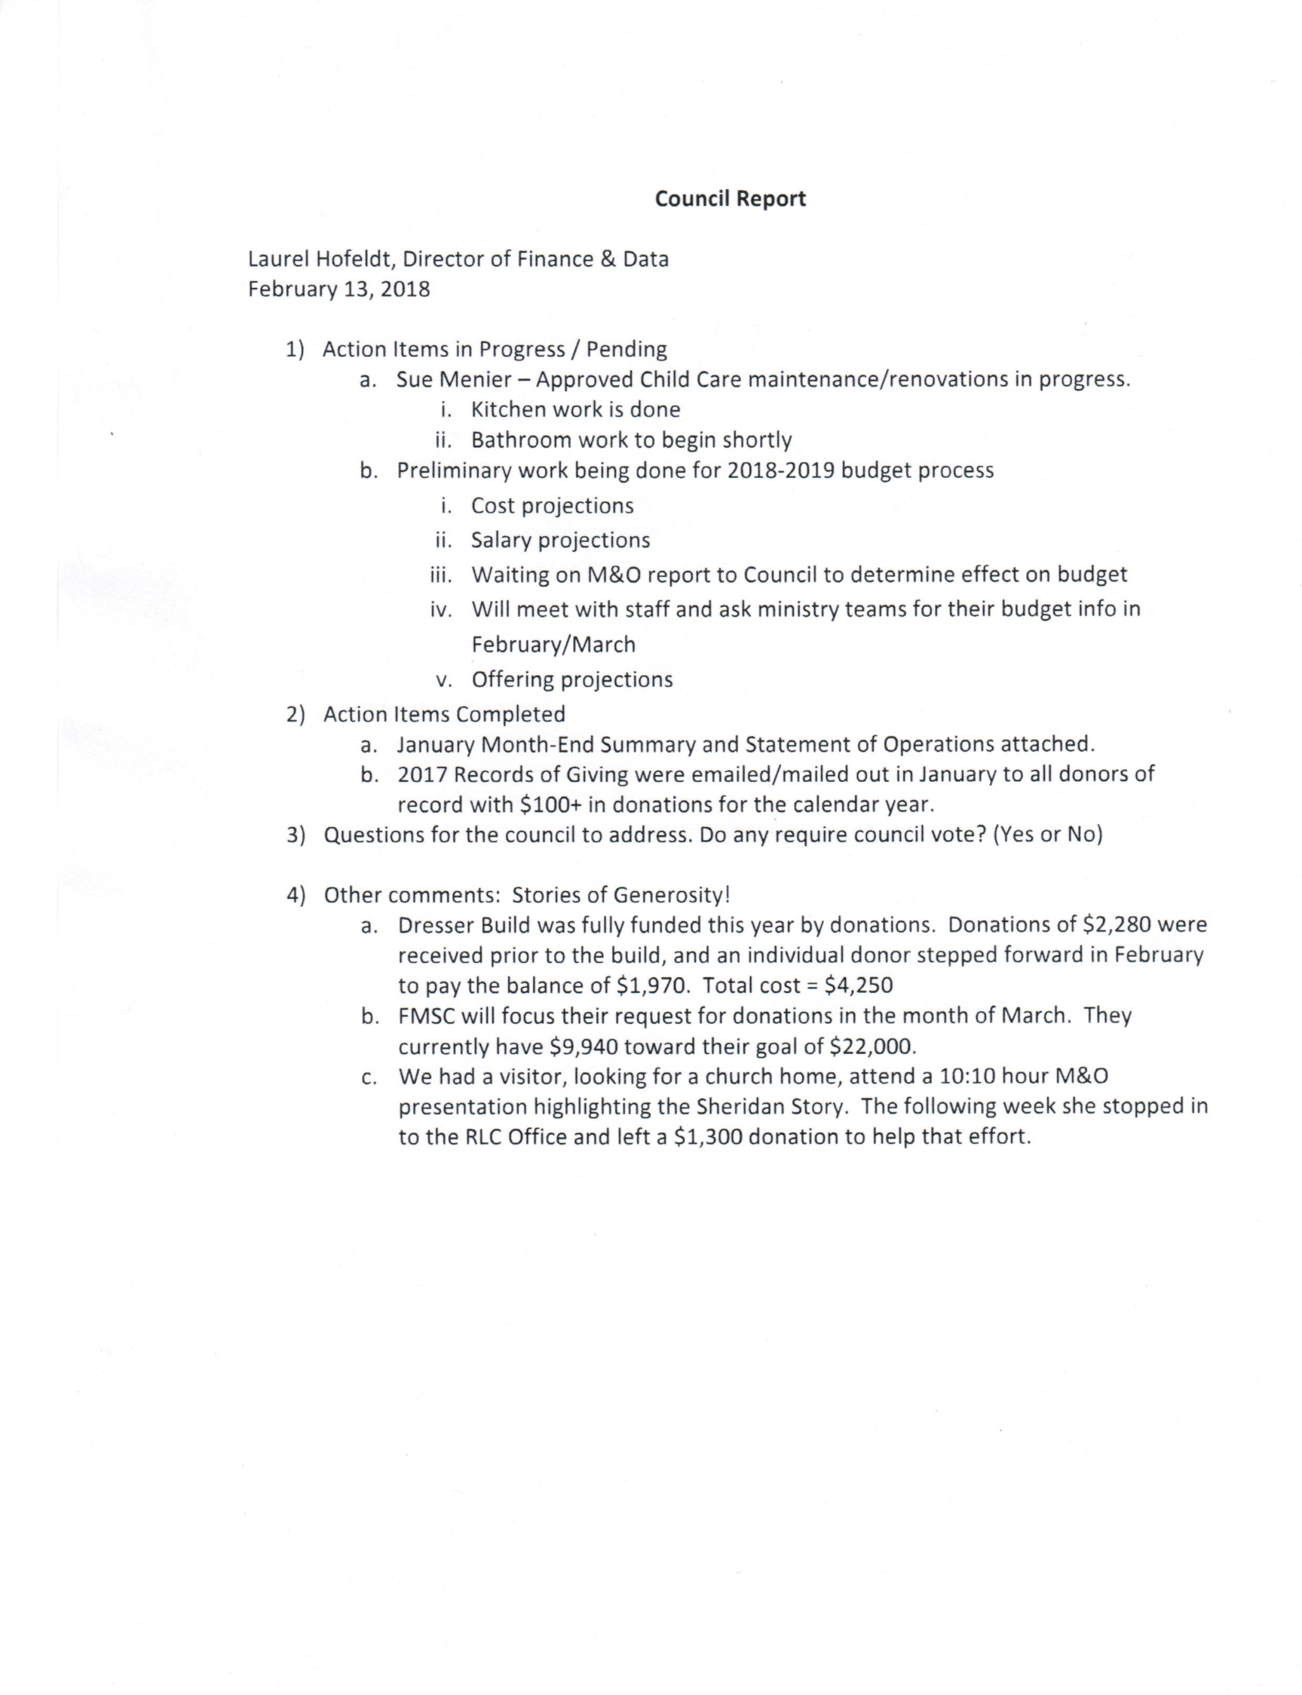
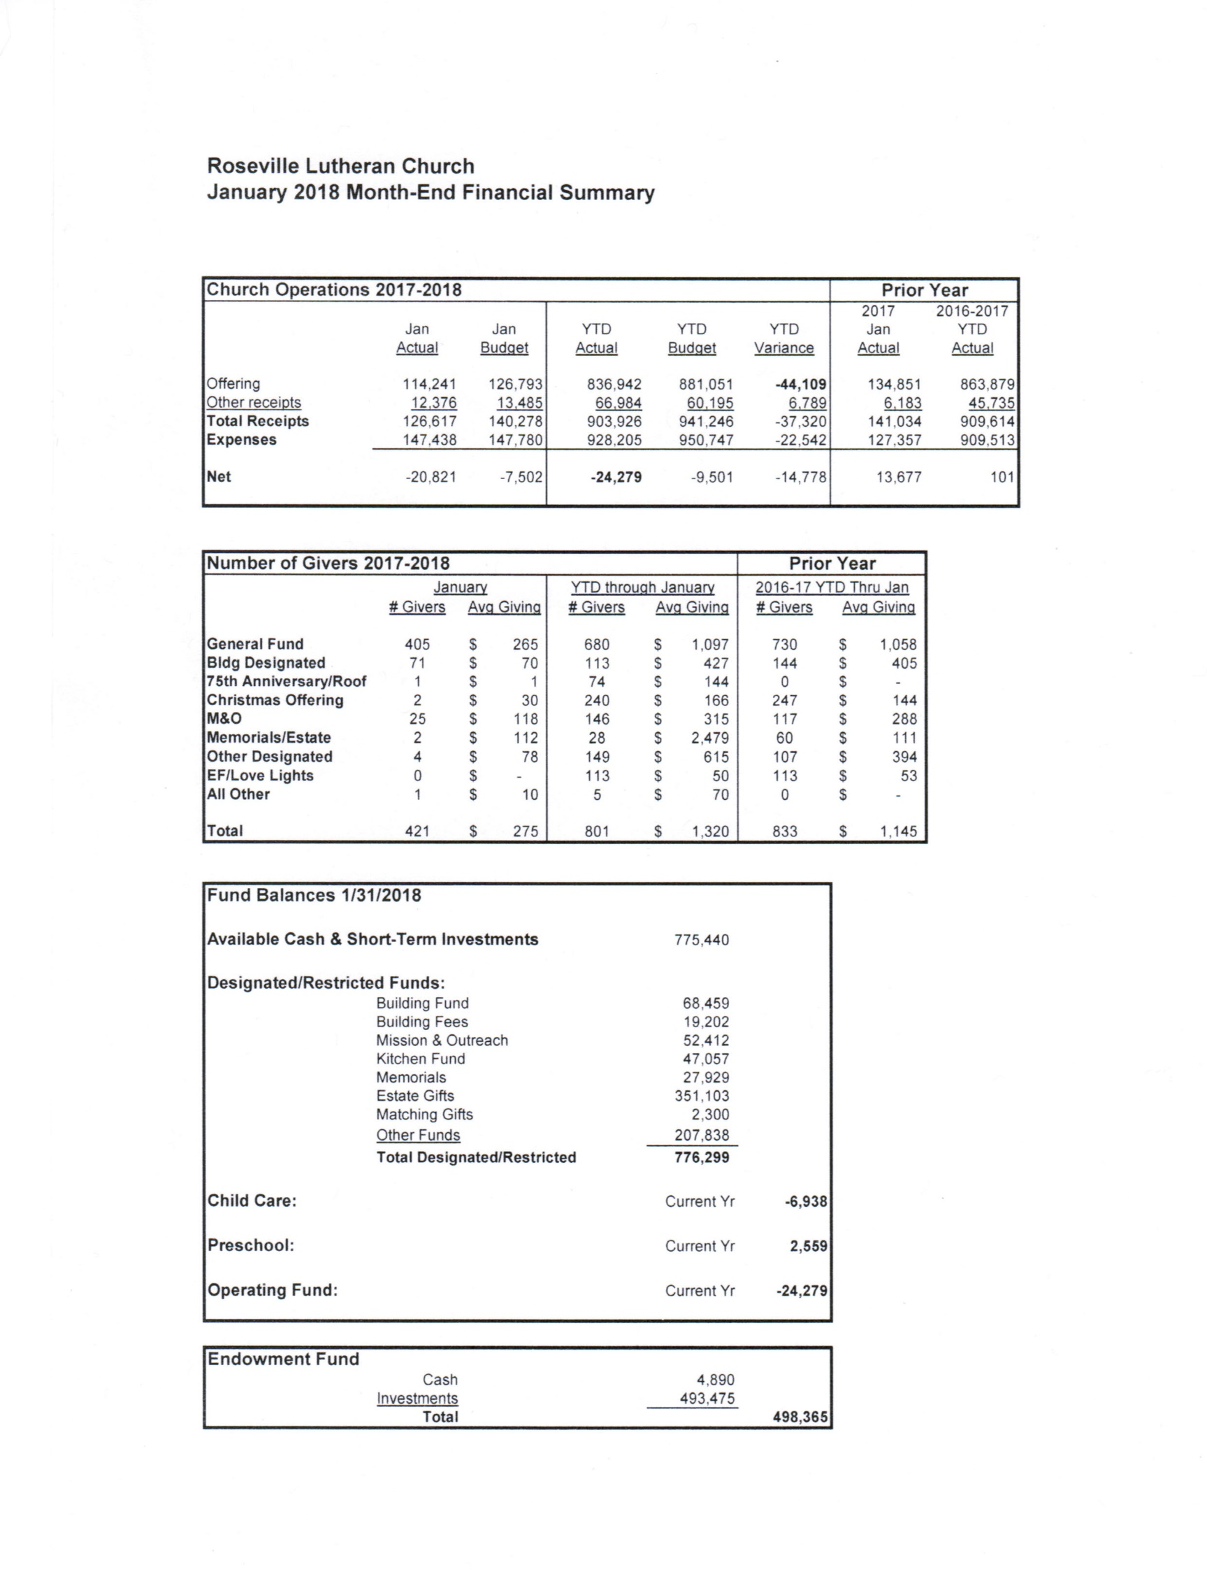
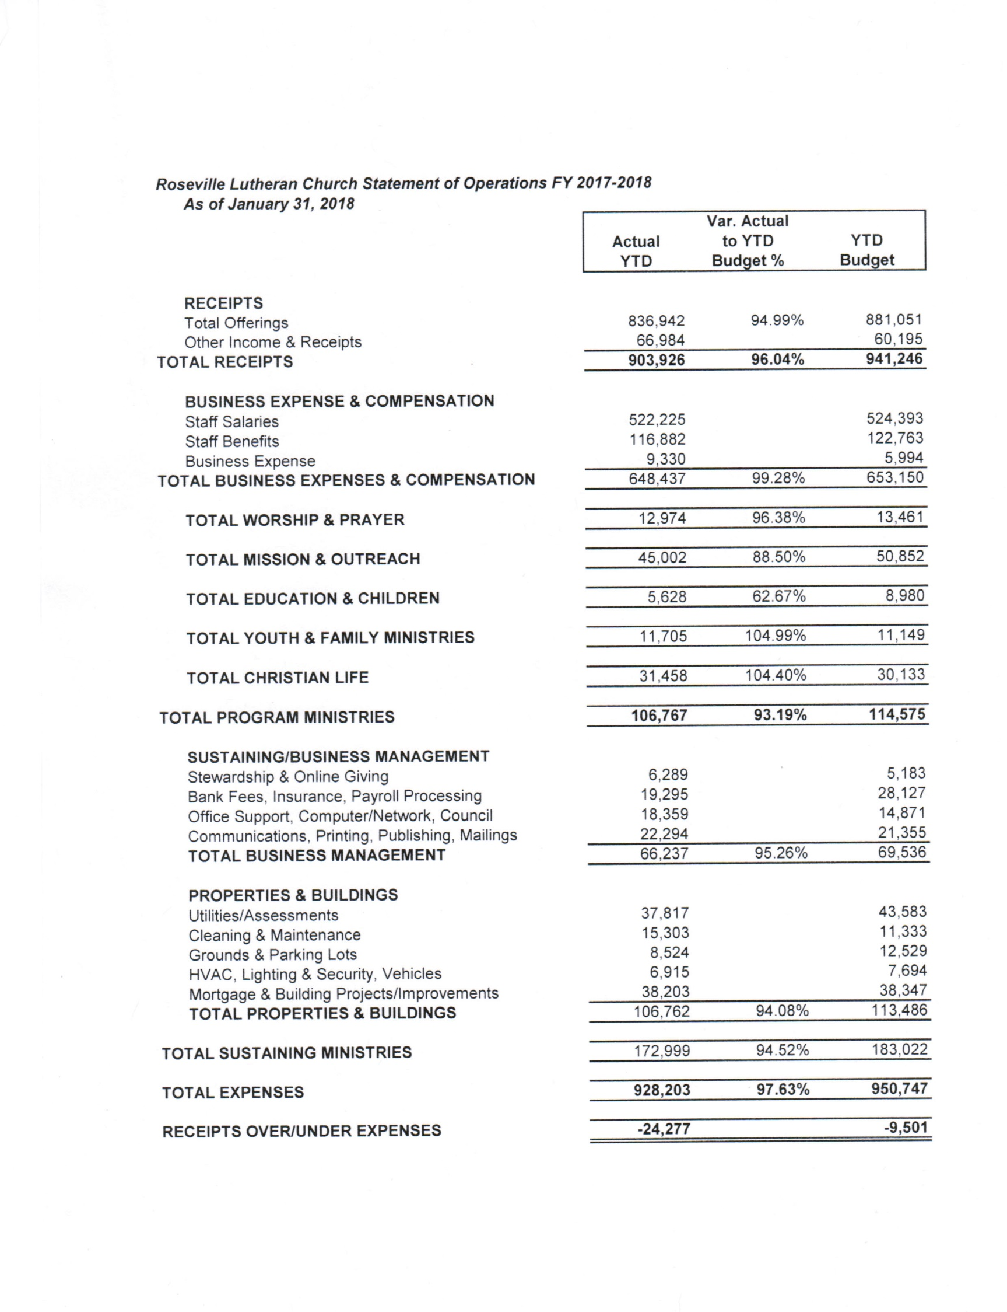
MONTHLY MINISTRY TEAM AND COMMITTEE LIAISON REPORT
Date of Church Council meeting: 2/15/18
Committee or Ministry Team Name: Children’s Ministry
Members Present: Rebecca Field, Nancy Brown, Kate Snavely, Howie Padilla, Joe Zeigler, Julie Hanson
Prepared By: Joe Zeigler
Date of the last meeting: 2/12/18

Summary of topics discussed, and activities that have occurred since the last meeting:
Children’s Ministry Advisory Board Minutes, February 12, 2018
- Opening Devotion from the Lenten Devotional booklet available for kids and their families at the Children, Youth and Family desk.
- Welcome Rebecca Field to the team! Rebecca and her family have been members at RLC for about 4 years. She and her husband have 2 daughters, Jaelyn age 4 and Kyrie 2. Jaelyn is in a 3 Yr old group in Cornerstone and attends RLC Preschool. Rebecca works part time for Clifton, Larson, Allen as a CPA. Welcome and thanks for joining us Rebecca!
- Julie led Council on a tour of Cornerstone, Luther League and Devos & Donuts during the 10:10 hour on January 28, to observe and assess how well RLC facilities serve the needs of our youth programs.
  - Council reps: Mike Dolan, Jess Henry, Keith Gilbert, Joe Zeigler
  - Stops:
    - Preschool Large Group Opening in Room 45A
    - Large Group for elementary kids in Activity Center with distribution of kids into small group in Activity Center
    - Ark Alley and our preschoolers in Room 66 and preschool classrooms
    - Luther League in Heritage Hall
    - Devo’s and Donuts in Great Hall

  - Julie to visit area churches in April and May to observe their set-ups for Children’s Ministry and see how their check-in systems are implemented.
- 75 Hours of Giving campaign. RLC task force to implement a giving campaign to help close the spring budget gap. Ideas were discussed regarding appeals to interest families with kids:
  - Quantify for people what certain denominations given will mean… a $25 gift can___ Give tangible things the money will go toward.
  - Let people know the various ways they can give. Promote more heavily the text to give.
  - Does the church track the different ways people give and how many? What percentage give via text, or online as a sustainer?
  - Website- it’s hard to find where to give- too many clicks.
  - Could RLC have an APP? Easy access to the website and giving, notifications of events, etc.
  - Ask kids to put together short movies with the theme “Why you should give to RLC”
  - Talent Show on Sunday night, April 22. Tickets sold go to 75 hours of Giving. 75 minutes long?
- Ideas to engage parents –Coffee Bar upstairs in Lobby with “good coffee” to get parents to stay during 10:00 hour and socialize. High top tables, seating similar to Caribou or Starbucks- couches, loveseats, comfy chairs. Invite people to stick around with irresistible place to gather.
- Update on facilities improvements-
  - Roof estimates being done, presentation by consultant to the new facilities task force regarding what needs to be done to the roofs. Leaking in Activity Center is getting worse and also leaking in Worship Center roof
  - Mother’s room: Bathroom downstairs near Social Hall to be remodeled to accommodate moms to nurse their babies or pump. Julie working with Steve Henry. Need to add an outlet, remove one of the toilet stalls and toilets, add rug and other things to make the room “softer” with the lovely blue tile that is there. Recommended to add a small refrigerator too.
- CM Calendar highlights for March-July
  - Serve Sunday on April 15th – the Soap Scoop. Working with Keystone Community Services to help them meet their most critical needs. We will be repackaging powdered laundry detergent into smaller baggies for families, similar to a FMSC set up.
  - Peanut Butter Challenge. Launch Easter Sunday with goal to collect 2500 jars of peanut butter by April 15th. Different groups will be challenged- Cornerstone small groups, Luther League, high school, general congregation. A big display in the Commons for all to see!
- Next Meeting is scheduled for Monday, April 9th at 6:30 in the library

Summary of upcoming events, or issues that the Church Council should be aware of:
Weekly Programs:
Sundays – Cornerstone, Luther League, Devos & Donuts, 11 & Lunch (2 yr. olds thru 8th Grade)
Mondays – Holy Hoops Practice (High School)
Tuesdays – FLOCK (High School)
Wednesdays – Confirmation (7th – 9th Grade)
Thursdays – Bagels @ Dawn (High School)

Special Events & Retreats:
March 7 No Confirmation (Spring Break)
March 24 9:00 a.m. First Communion Workshop
March 25 9 & 11 a.m. Palm Sunday – Palm Procession
March 28 No Confirmation (Holy Week)
March 29 6:00 p.m. Seder Meal and First Communion
March 30 10:00 a.m. Good Friday Family Worship
April 1 No CYF Programming (Easter)
April 8 1:00 p.m. Holy Hoops Tournament
April 15 10:00 a.m. Serve Sunday: Soap Scoop
April 18 7:00 p.m. Confirmation Fellowship Night
April 21 9:00 a.m. Peer Ministry Leadership Retreat
April 25 6:30 p.m. 9th Grade Confirmation Rehearsal
April 29 11:00 a.m. Confirmation Sunday
May 6 10:00 a.m. Luther League Intro (for 4th graders & parents)
11:00 a.m. Graduation Recognition Service
3:00 p.m. High School Mission Trip Meeting
5:00 p.m. Boundary Waters Trip Meeting
May 9 7:00 p.m. Hiawatha Youth Leader Meeting
May 20 10 a.m. Last day of Cornerstone, Luther League, Devos & Donuts
11:00 a.m. Cornerstone & Luther League sing in Worship
May 22 7:30 p.m. Last day of FLOCK
May 24 6:45 a.m. Last day of Bagels @ Dawn
June 10 9:00 a.m. Hiawatha Youth Leader Meeting
June 11 – 15 Vacation Bible School

Does the group have any questions, or concerns to bring to the Council? Is there anything the Council, or staff can do to assist the group?
To accommodate over 160 kids in age-appropriate groups from ages 2 through 12+, Cornerstone and youth activities are divided into remote corners of our facility. This presents some issues.
- Security. Ideally, a centralized location would allow better oversight as parents drop off and pick up, especially younger children – similar to how K through 12 schools currently operate. The spread of individually-shepherded groups throughout the facility, with multiple entry and exit points, compromises the ability of staff and Shepherds to track and monitor attendance and departures. Julie will be observing how other area churches manage this, with a plan to implement new protocols in the fall.
- Staff ability to manage activities. Julie and Abby do an amazing job with the resources they have. However, much of their time and effort between the hours of 10 and 11 on Sundays is spent managing the activities of numerous groups at opposite ends of a multi-level football field, and at many points between the end-zones. If a Shepherd has a question or needs assistance, it is unlikely that a staff member can be there to assist.

Other issues observed by Council reps during the Jan 28 tour:
- Additional audio/visual capabilities in the “40” rooms. Some of the lower-level spaces were unoccupied during the tour. Improved AV resources within the lower level rooms could make them more appropriate for Cornerstone and youth activities.
- Activity Center. It is noisy. And dimly lit. And the roof leaks.
- Meeting spaces are needed to accommodate individual small groups. The noise and distraction of multiple active groups in the Activity Center and Heritage Hall are not conducive to learning.

Recommendation:
To the Campus Improvements Task Force, assign at least one individual to advocate for Children’s Ministry and Youth Programs. This person(s) will ideally be an educator – we have many teachers and school administrators in our membership to choose from. They can offer perspective as to how RLC can best provide spaces and resources that will empower staff and Shepherds to continue and grow this vital ministry.

