Date: December 14th, 2017
- Call to Order
Jeff Johnson called the meeting to order at 7:05pm.
- Devotional / Shared Prayer
Tom Lund led us in prayer.
- Establish a Quorum
  - Members present: Jeff Johnson, John Shardlow, Mike Dolan, Beth Jacobson, Keith Gilbert,
Jessica Henry, Joe Zeigler, Tom Lund, Darci Bontrager
  - Members absent:
  - Others present: Pastor Lauren Wrightsman, Pastor Sara Spohr, Dave Booms, Laurel Hofeldt
- Approval of Agenda
A motion to approve the agenda was made by John and seconded by Tom. The motion was approved unanimously.
- Approval of November minutes
A motion to approve the November minutes was made by Mike and seconded by Joe. The motion was approved unanimously.
- Eagle Scout Presentation for Pauly Soulia
Pauly Soulia, his father, brother, and Scout advisor joined Council to thank the church for the opportunity to complete his Scout project, the landscape work done on the north side of the sanctuary. A plaque will be placed outside in the area to commemorate the project. Pauly was thanked by Council.
- Monthly Reports
Staff reports are attached. Any additional discussion is listed below.
  - Finance
  - Staff
      - Pastors
        - Senior Pastor
          - Stewardship Update
Mission and vision roles within stewardship are being adjusted to better support future giving campaigns.

          - Innovations in Management
There will be conversations in January for staff, Council and lay leadership to discuss observations made by Innovations staff.

        - Associate Pastor
      - Church Administrator
Dave commended the staff for how well the anniversary celebration went and that Advent and Christmas planning are progressing. The Council wholeheartedly agreed, with several members sharing their appreciation for the Anniversary committee and staff. Thank you cards were signed by Council members for both the committee and staff.

  - Committee Reports
Any reports are listed below if given.
    - Mission & Outreach- Darcy
    - Stewardship- Keith
Two meetings were held in the last month. More information will follow.
    - Children- Joe
Cornerstone space use should be considered for any future building upgrades. A January 28 tour of classrooms is being arraigned to show current usage.
    - Youth & Family- Jessica
Scholarship and other policies are being clarified before future program sign up.
    - Adult Ed- Beth
The adult schedule is being clarified and hopefully tied to sermon topics
    - Christian Life- Beth
Scheduling for Restaurant week is proceeding for January. A sign up for a bowling event in February is coming.
    - Nominating- Mike Tom
John suggested Council assist in finding a better way to communicate nominating. Pastor Lauren suggested coming up with names within Council and working with Nominating to find candidates. The discussion included the importance of asking individuals in addition to general requests of the congregation. A meeting in early January will be set up.
    - Task Force Updates
      - Strategic Planning:
        - Mission and Outreach Taskforce update
Meetings have taken place since August. Plans are to be presented to Exec in February and Council in March. Strategic filters using our refined mission will help decide and focus on programs to rally around, and which recommendations to carry out. A transition team will likely be needed to shift programs for as many as 18 months. The taskforce will hopefully be used as a model for other task forces.

        - Facilities and maintenance task force
Steve will be tasked with giving a prioritized list of deferred maintenance areas from those already described. There are many ideas on improvements. Immediate needs would come first but the task force will look at future improvements even as immediate needs are met. Ideas to pay for improvements ranged from loan refinancing to using several large unrestricted gifts. Recognizing those from whom the gifts came is important and can encourage future giving. What expertise task force members should have could include environmental, architectural areas.

      - 75th Anniversary
The celebration was unanimously recognized as a great success.
- Items for Discussion
  - Comments about Council facility tour
Further comments were generally stated about the need for addressing deferred maintenance areas. Gifts can and should be used instead of using them piecemeal or not at all.
- New Business (Action Items)
The IRS requires approval of the Pastoral housing allowance by Council. A motion to approve the allowance was made by Tom and seconded by John. The motion was approved unanimously.
The attached request to approve funds for the painting frame was already approved by Exec on 12/7/17.
- Upcoming dates
- Adjournment
A motion to adjourn was made by Joe and seconded by Beth. The motion was approved unanimously.
- Closing Prayer
A candlelit prayer was led by Pastor Sara.

Respectfully submitted,
Mike Dolan
Council Vice President
Roseville Lutheran Church

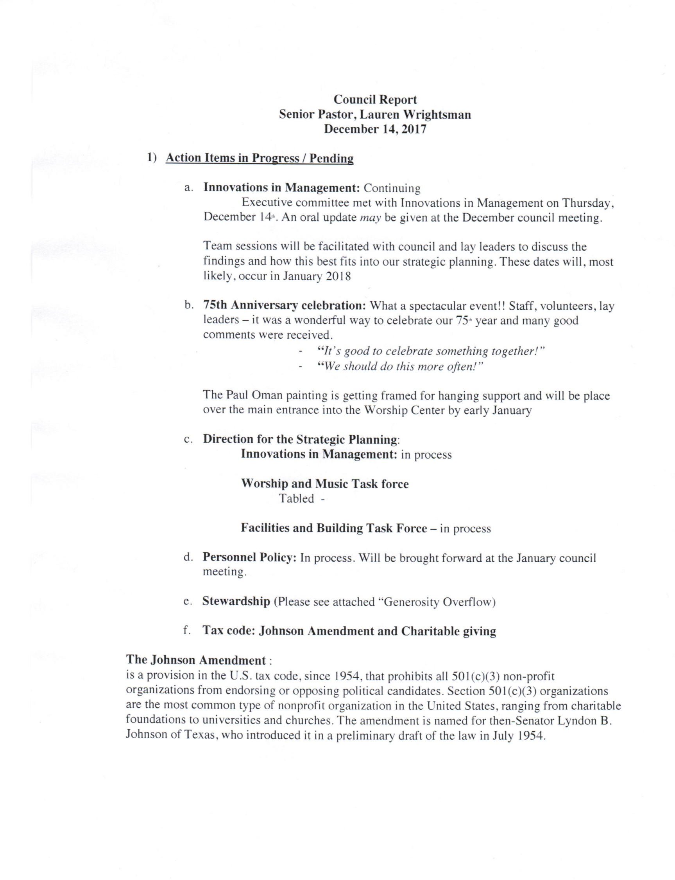
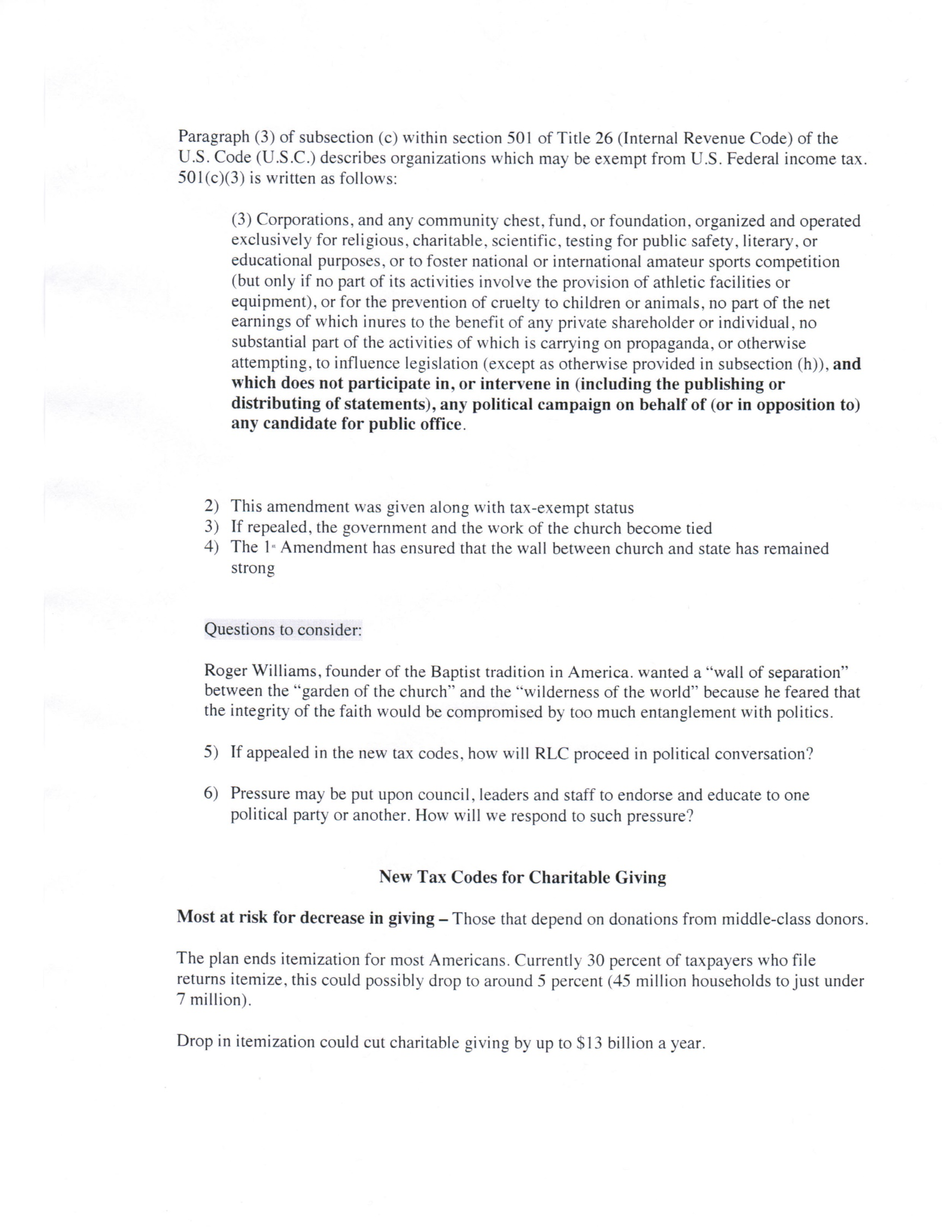
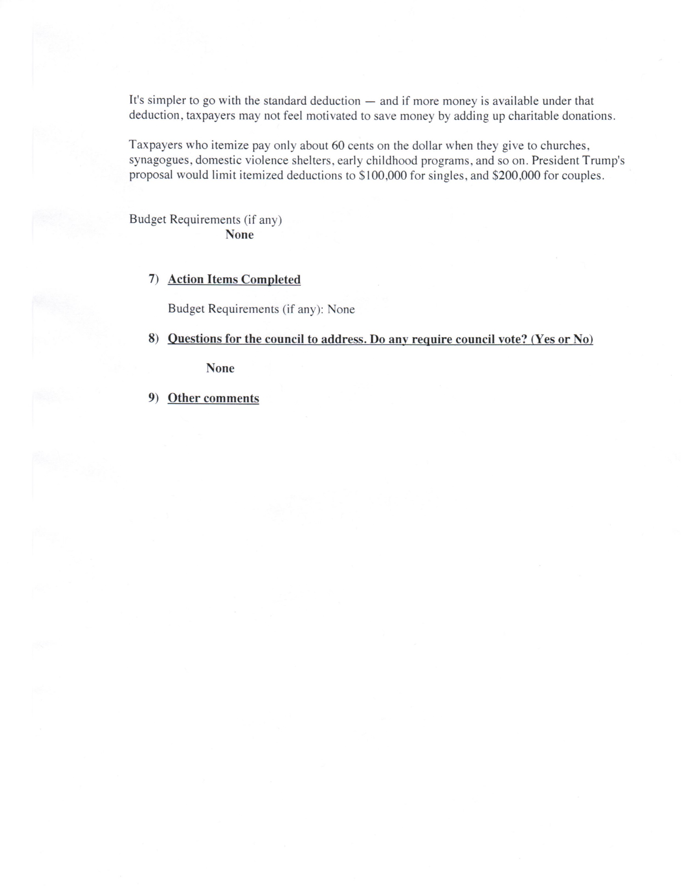
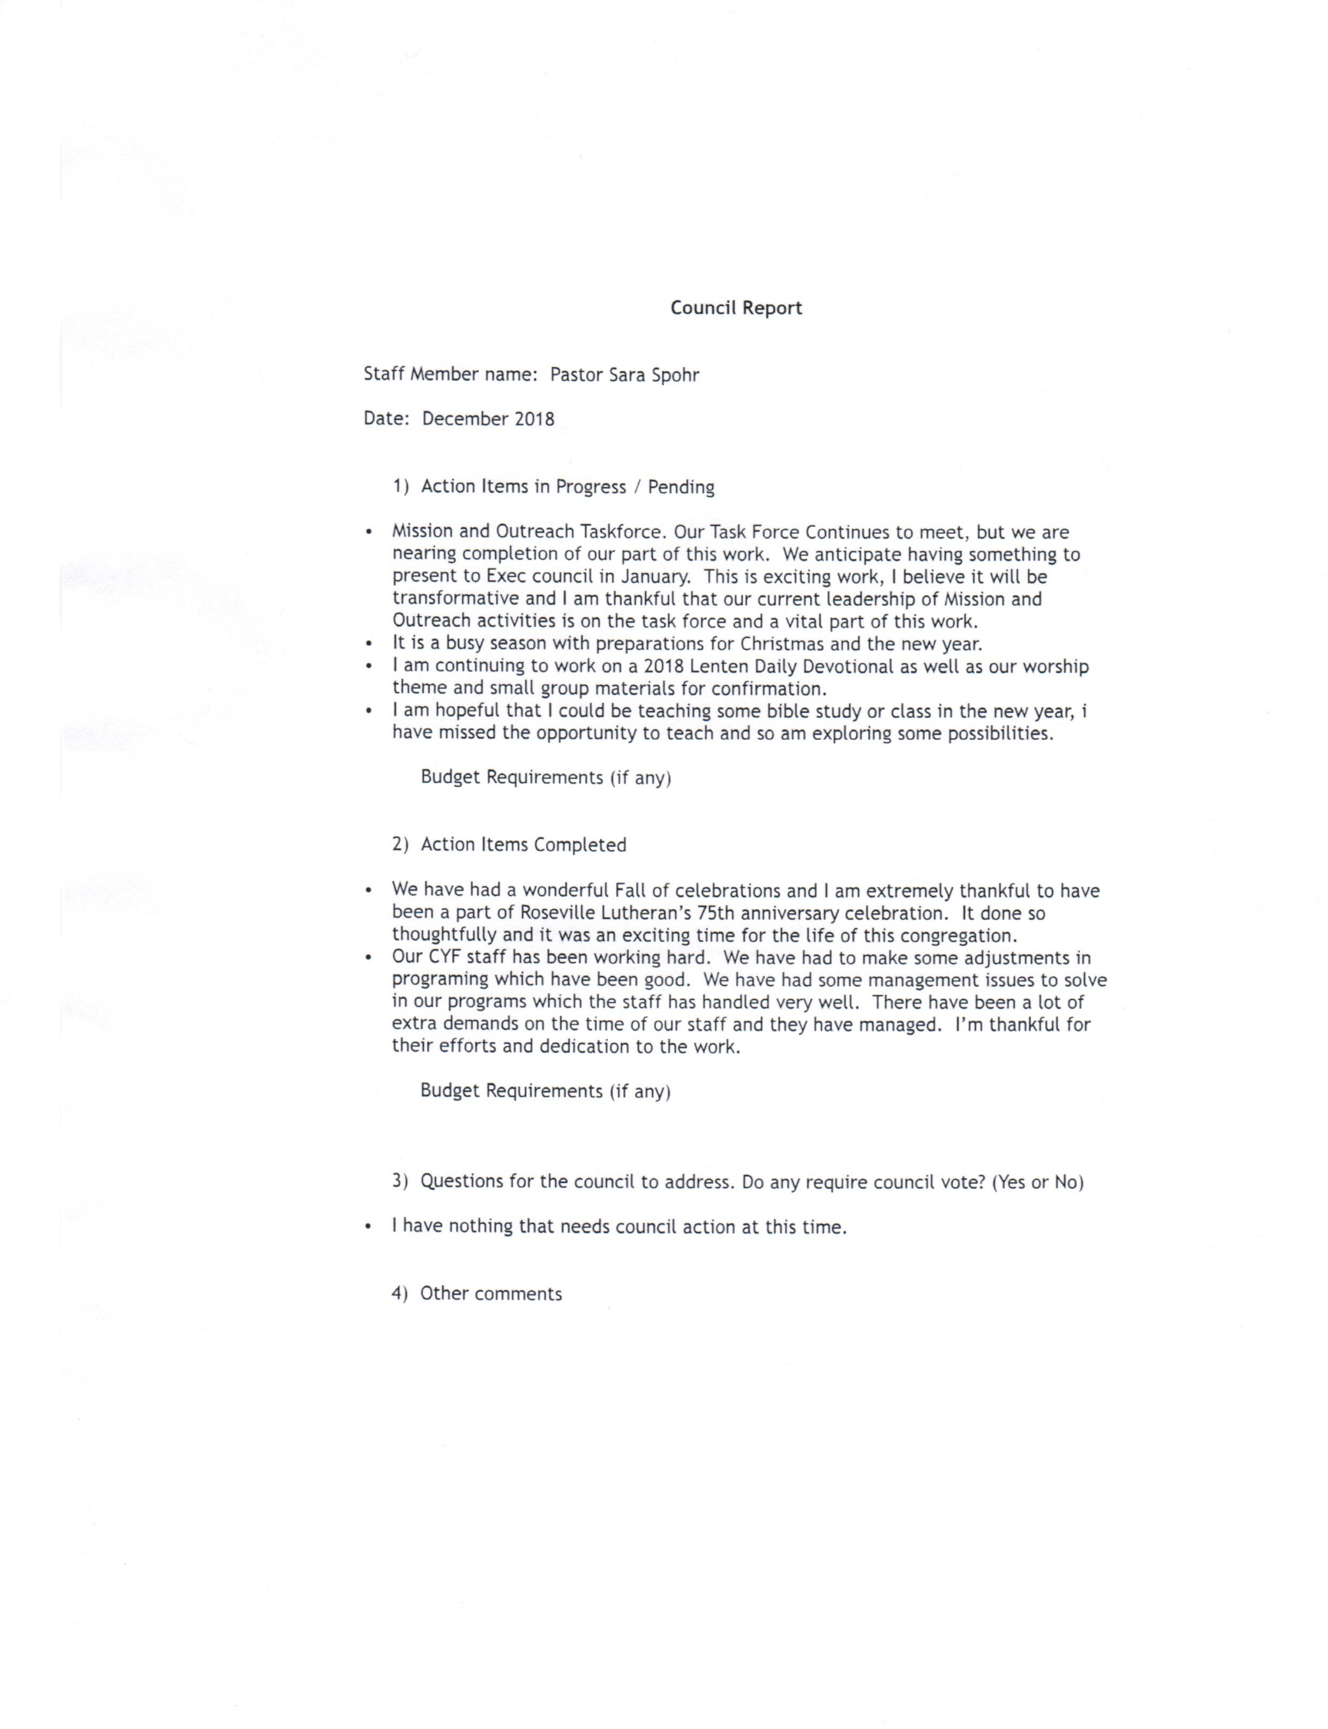
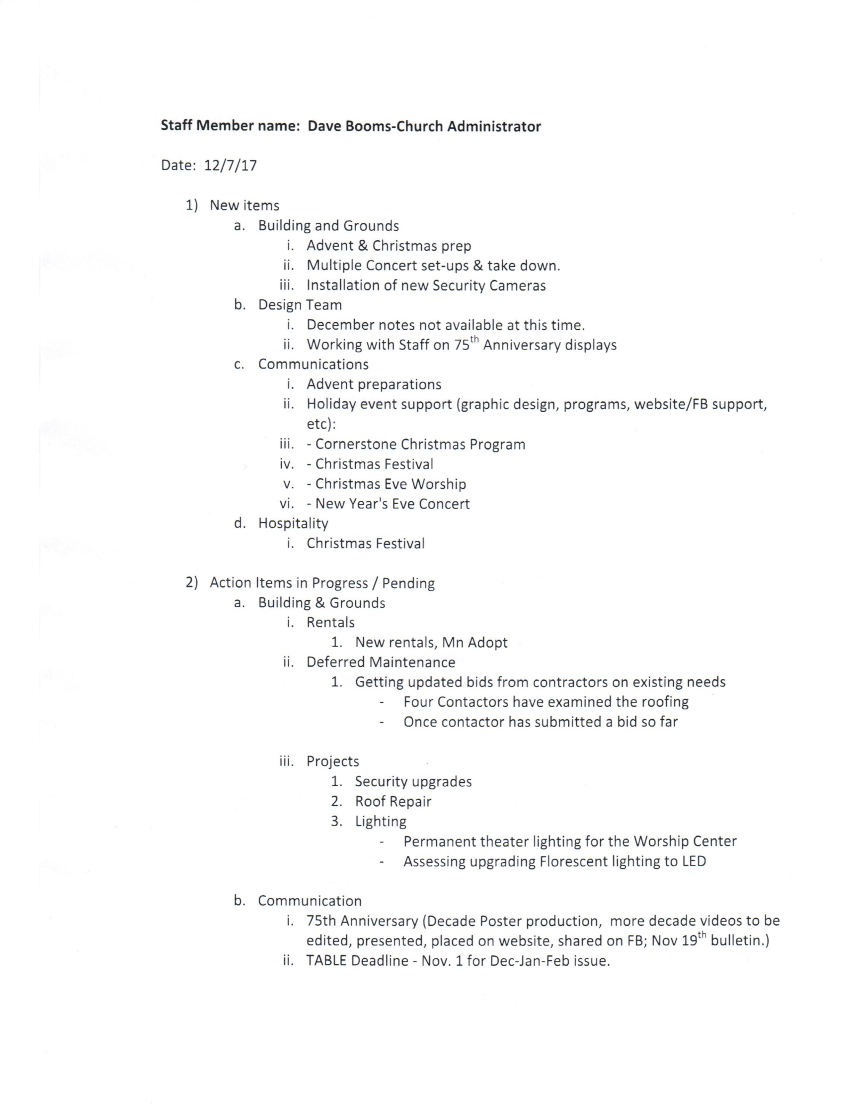
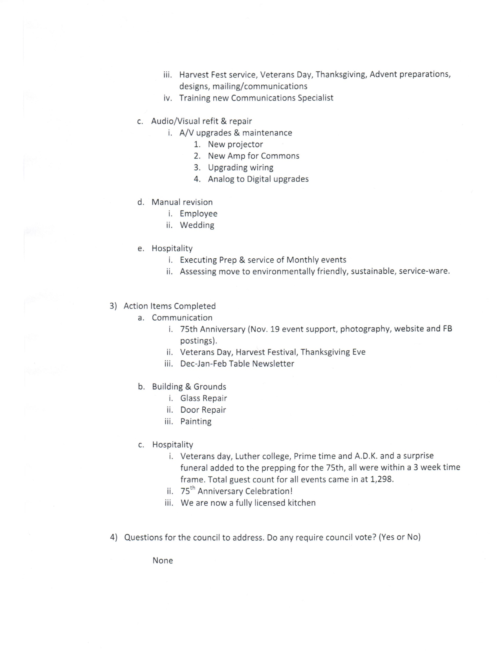
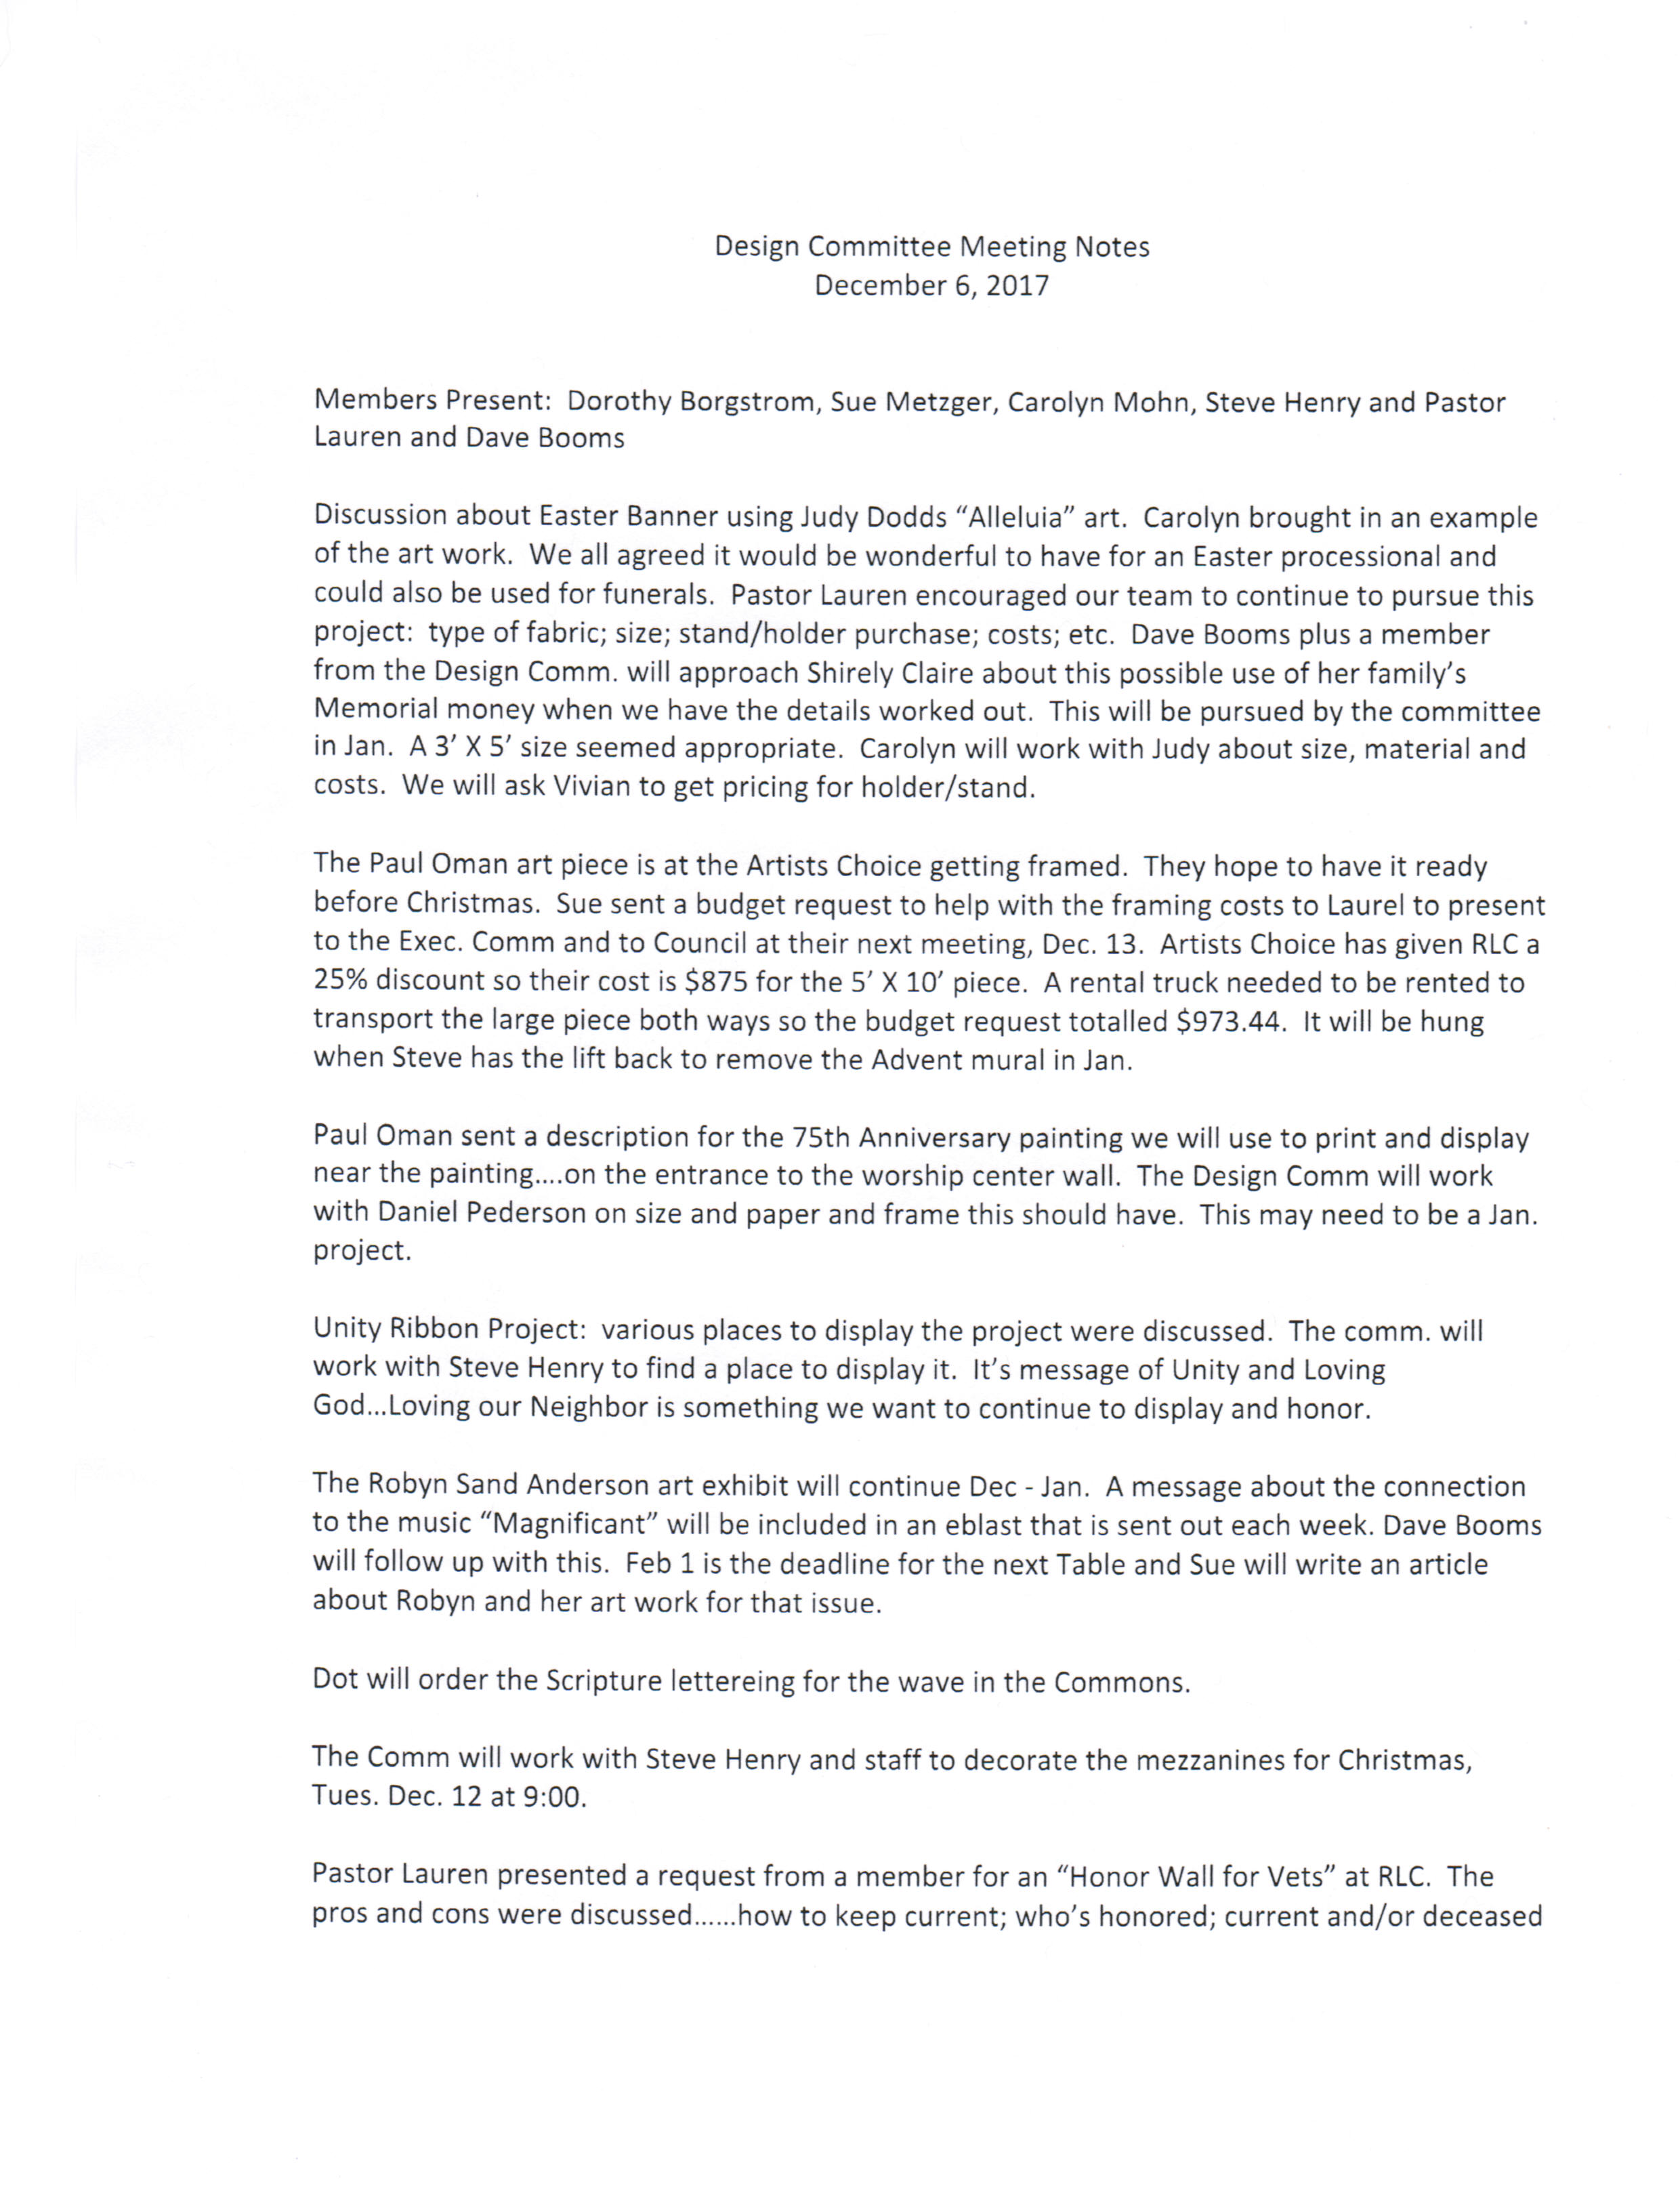
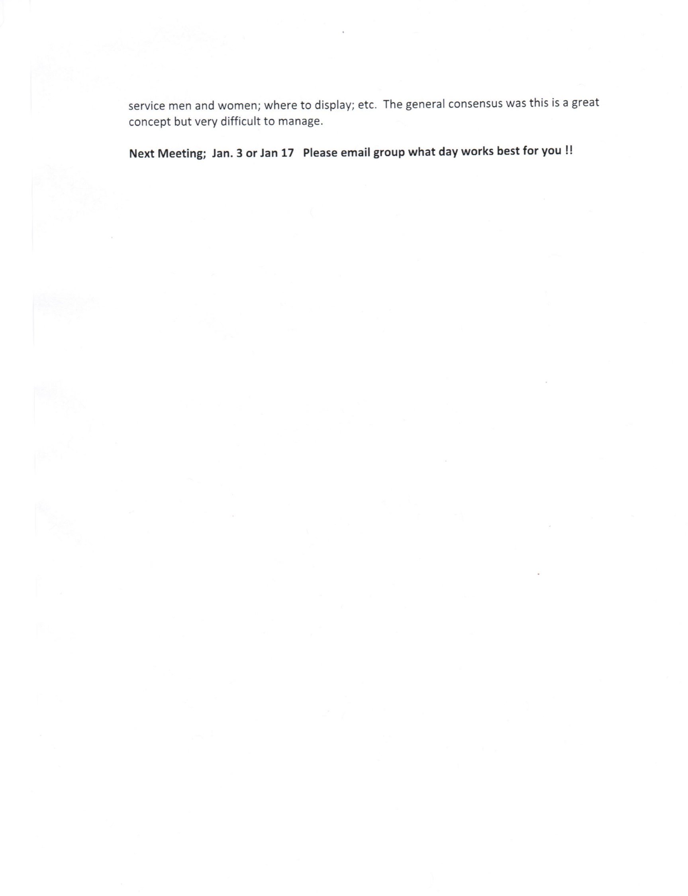

Council Report

Laurel Hofeldt, Director of Finance & Data
December 11, 2017

- Action Items in Progress / Pending
  - Sue Menier – Approved Child Care maintenance/renovations in progress.
  - Stewardship/Intent to Give update as of 12/11/17:
    - 229 intent cards turned in (including online givers who did not turn in a card we have 368 commitments for 2018)
    - $610,000 in giving committed to the general fund; add online giving past 12 months for those who didn’t turn in card of $270,000 we have $880,000
    - $18,500 committed to the building fund
    - 96 donors plan to increase their giving over 2017 plus 6 new online givers. We have achieved our target of 100 new/increased sustainers!
- Action Items Completed
  - November Month-End Summary and Statement of Operations (attached). Note that November offering was almost $27,000 below budget, due primarily to:
    - November 2016 we had Give to the Max campaign, which brought in $8,000 offering in November (matching and direct gifts) and another $8,000 offering in December (gifts to the GiveMN.org website)
    - A single large annual gift from November 2016 came in October 2017. (Remember October 2017 offering was over budget by $10,000)
    - 75th Anniversary offering of $6,000 (so far) went to the Building Fund for roof repair instead of into general offering.
- Questions for the council to address. Do any require council vote? (Yes or No)
  - Approval of Pastoral Housing Allowances requires vote
  - Funds for framing of Paul Oman art piece (see proposal attached)

- Other comments:

BUDGET REQUEST PROPOSAL FOR RLC COUNCIL CONSIDERATION

The Design Committee has an expense for a simple frame for the 5’ X 10’ Paul Oman painting from the 75th Anniversary Celebration.

We are asking council to budget the invoiced amount of $875.00 to frame the Paul Oman art piece at Artists Choice Framing and $98.44 for the round trip U-Haul truck rental which equals $973.44 total….. or a portion of these expenses.

We recognize there has been a recent donation to the Design team’s restricted fund. We also are aware of more requests for updating and inviting art work in the main office as well as future needs the design team might be asked to address and fund.

Attached is the invoice from the framer (Artists Choice) and U-Haul truck rental to deliver the large art piece to framer (which will be doubled for the return trip!)

Thank you for your time and consideration of this request.

Sue Metzger for the committee

