Date: September 21, 2017
- Call to Order
Jeff Johnson called the meeting to order at 7:02pm
- Devotional / Shared Prayer
Pastor Lauren led us in prayer
- Establish a Quorum
So noted
  - Members present:
Jeff Johnson, John Shardlow, Mike Dolan, Keith Gilbert, Tom Lund, Jessica Henry, Dari Bontrager, Beth Jacobson.
  - Members absent:
Joe Ziegler
  - Others present:
Pastor Lauren Wrightsman, Pastor Sara Spohr, Dave Booms, Laurel Hofeldt, Rich Wendland.
- Council expectations and procedures
Pastor Lauren outlined expectations, procedures and content of the 2017-18 Lay Leadership Handbook.
Of note, the annual meeting is tentatively set for the 4th Sunday in June. Attendance is needed.
- Approval of Agenda
A motion to approve the agenda was made, seconded and approved. The vote was unanimous.
- Endowment update: Endowment Committee Representative
Rich brought samples of a bookmark to place in hymnals for 9 am worship. An 11 am worship handout is yet to be determined. The bookmark will help bring more visibility toward Endowment. In addition, In Faith has presented information the previous evening to enhance visibility for Endowment. The committee is looking at it but no decision has been made. Minimum investment of $25k. Presentations and printed materials provided. All materials go toward donated funds but can be used as a guide for remaining Endowment. Endowment is continuing to look at all the details. No further action taken at this time.

- Approval of August minutes
A motion to approve the August minutes was made, seconded and approved. The vote was unanimous.
- Monthly Reports
Finance and staff reports below are attached. Any other related comments are shown below.
  - Finance: Laurel
  - Staff
      - Pastors
        - Senior Pastor
Personnel policies are being evaluated and updated.
        - Associate Pastor
      - Church Administrator
75th anniversary and fall activities are in full swing. Daniel Peterson’s work on the glossy mailing was of special note and complemented by members and staff.
      - Other
Design committee report is attached.
  - Committee Assignments
The following assignments were made; members assented to them as shown. Reports are shown if made. Dave suggested committees update their membership lists and get this information to him.
    - Mission & Outreach- Darci
Darci reported on a meeting last month. Some question by the committee on giving toward ELCA. Speakers will be coming in October. Committee is looking for greeters, email request will be sent.
    - Stewardship- Keith
Keith passed out cards for sending thank you notes to sustaining givers.
    - Children- (Joe)
    - Youth & Family- Jessie
Jeff read an email from Michael Jordan, summarizing this past summer’s activities and what’s next:
We ended in the black combining all 5 of our summer Youth & Family Trips this year. The total cost of all 5 trips was $61,314. It was great being able to help families offset that cost through the Invest in Our Youth envelope campaign back in February as well as our Gift Card Fundraiser. A summer 2018 preview brochure will be available in early October. We're going to have the youth fill out the thank you cards for the Stewardship Thankathon campaign. One of the focuses this year for the Youth & Family Team will be on our current policies and statements. We will be updating them and creating new ones as they come. All of our fall programs have kicked off now, and we're excited for the year ahead!

    - Adult Ed- (Beth)
    - Christian Life- (Beth)
    - Nominating- Mike (Tom)
    - Endowment currently does not have a liaison but has in the past. Endowment will be asked if they would like to resume having a Council member attend.
    - Task Force Updates
      - Strategic Planning:
        - Mission and Outreach Taskforce update
Pastor Sara reports that M/O has met four times, providing filters and a criterion for work by RLC. Recommendations and activities will be pursued with deep impact. Funds should go into areas where we are serving and where we can share the story. Engage more people for impact. Governing structure may need to be overhauled. Many ideas being generated for future, impactful activities. Tom suggested that RLC be recognized clearly in activities, and make sure recommendations come back to Council.
        - Worship/music/Wednesday evening committee
Pastor Lauren reported that conversations are ongoing and more will be reported later.
        - Facilities and maintenance task force
Immediate roofing and foundation issues exist and need immediate action. While the taskforce hasn’t been populated, Exec has approved obtaining bids and moving forward with immediate repairs. As work progresses, some effort will be made to observe the feasibility of structures on the roof, for example, for evaluation of future possible additions (i.e. solar panels, for example).
Dave reports Steve Henry is moving toward more efficient lighting as part of taskforce. The taskforce will be designed to augment Dave and Steve’s expertise with other experts.
      - 75th Anniversary
Pastor Lauren reports continuing planning; dance and concerts coming up in the next several weeks.
- Items for Discussion
  - Committment2Community
John outlined the ISD 623 building referendum and passed out an information sheet on the bonding vote on November 7th. John asked if he could discuss the issue within RLC (10:10 hour) or the equivalent. The discussion centered around whether the 10:10 hour should be reserved for more faith related topics. While there was no specific agreement, there was general approval of encouraging the congregation to learn about and participate in discussions about the referendum prior to the vote.

- New Business (Action Items)
  - All are welcome to be married at RLC
Pastor Lauren outlined a change in the marriage policy, allowing members and non-members alike to be married under the same policies and rates. This does not change building policies, only those related to marriages. A motion was made to change the marriage policy to allow member and non-member couples to marry under the same policy was made and seconded. The motion was approved unanimously.
  - Innovations in Management
As part of strategic planning, consultants would help with conversations between staff and lay leadership. Set up listening sessions and meetings to help conversations about where we are at and how to move forward. The request is for $10k. Estate gifts would fund the program. Improve working relationships and observed disconnect between what staff is doing and what lay leadership is doing. Questions were taken about the specifics of what will be offered. The staff and Pastors were in agreement of the need. A motion to approve $10k for Innovations in Management to provide consulting services was made and seconded. The motion was approved unanimously.
  - Funds needed for 75th Anniversary servers
Dinner activities during the anniversary will need hired servers so everyone can participate. The budget was discussed (see attached). Looking for up to $2000 from Memorial gifts. A motion was made to approve $2000 from Memorial gifts for the 75th anniversary celebration was made and seconded. Further discussion centered around giving an opportunity to donate toward the general fund, starting the first Sunday. The motion was voted on and approved unanimously.
- Upcoming dates
  - Stewardship (already in progress)
  - Adult ED Genesis 12-50 The Promise September 24, 10:10 A.M.
  - 75th Anniversary Events
    - September 30, 7 P.M. RLC Swing Dance (Worship Center)
    - October 14, Ken Medema Concert
- Adjournment
A motion was made to adjourn. The motion was seconded and approved unanimously.
- Closing Prayer
Pastor Lauren led us in the Lord’s prayer.

Respectfully submitted,
Mike Dolan
Vice President
Roseville Lutheran Church

Council Report
Senior Pastor, Lauren Wrightsman
September 14, 2017

- Action Items in Progress / Pending

PLEASE SEE THE ATTACHMENT / PROPOSAL FOR INNOVATIONS IN MANAGEMENT DISCUSSION

  - Innovations in Management: Exec met with IM along with Dave Booms and Pastor Sara Spohr. Sara and I also had an opportunity to meet with IM together to work though how they see this moving forward and both of us feel comfortable with their proposal.

Executive approved of the proposal and this proposal will be brought to council at this months meeting for a vote.

  - 75th Anniversary celebration: Continued work with this team is ongoing. Pastor Sara, John Helgen and myself have worked through a mock-up of the 75th anniversary worship on November 19th.

  - Continued work with Stewardship to address the campaign going into the fall

  - Direction for the Strategic Planning:

Worship and Music Task force
I will be bringing to council (at a future date) a draft of a charter for the Worship and Music Task Force. This task force will be responsible for assessing current worship services and project a plan for the future.

  - Member / Non-Member Wedding Policy: Pastor Sara, John Helgen, Dave Booms and myself have updated our marriage policies. I will be bringing to council a proposal to open our marriage policy to include “Members and non-members”. Currently there is a policy for member only weddings. In light of our vision / mission statement, I feel it is best to open our doors to all who are seeking RLC as a place for their wedding ceremony following our guidelines and expectations that it be a Christ-centered wedding, with our pastors officiating.

  - Personnel Policy: Laurel Hofeldt, Dave Booms, Pastor Sara and myself have been re-working our personnel policy. It is almost complete.

Budget Requirements (if any)

Innovations in Management
Proposal: I would suggest a budget of $10,000

- Action Items Completed

Budget Requirements (if any): None

- Questions for the council to address. Do any require council vote? (Yes or No)

Innovations in Management: YES: After we discuss the direction to take with outside resources for staff and Innovations in Management there will need to be discussion with council and approval of a budget line item. I would suggest looking at the memorials to pay for this budget item.

Marriage Policy: A vote will be necessary to open up the marriage policy to non-members.

- Other comments

Council Report
Staff Member name: Pastor Sara Spohr
Date: September 2017

1) Action Items in Progress / Pending
• I am continuing work with the Mission and Outreach task force and with planning
worship these for the Lent/Easter season.
• I participated in an excellent continuing education class in August that was focused
on staffing and supervision. I am eager to implement some of these learnings with
the staff I supervise. This would include updated job descriptions and collaborating
on a goal writing process. I appreciated the time to be away to learn these new
skills.
• Leadership - The CYF Staff team is still working to recruit leaders for all of our
programs. They are close, but have encountered some frustration with this process.
I am sensing a need for renewed inspiration for leadership across the spectrum of
programs and ministries in our church. The more people are called and equipped to
lead the more prepared we will be to carry out our mission.
• Continuing work to plan for Lenten them and Lenten devotional offering.
Budget Requirements (if any)

2) Action Items Completed
• The Unity Project begins this weekend. I have been working with a team of people
to put this project together. The focus comes form our Vision statement - “a
community united by grace.” The hope is that this piece of temporary artwork
would highlight the beauty that comes from both our differences and our
commonalities. Please plan to participate!
• We had a wonderful kick-off Sunday. Our staff teams put a lot of work into making
it a great welcome for all of our families returning to Fall programing. I was really
proud of the effort and the overall message and excitement in worship.
Budget Requirements (if any)

3) Questions for the council to address. Do any require council vote? (Yes or No)

4) Other comments

Staff Member name: Dave Booms-Church Administrator

Date: 09/14/17

- New items
  - Bldg. & Grounds
    - Deferred Maintenance
      - Getting updated bids from contractors on existing needs
      - Looking for an outside “expert” to help build and overall priority plan.
        - Steve is recommending that we address the Worship Center needs this Fall. Please see attached document.
    - A/V upgrades & maintenance
      - New projector
      - New Amp for Commons
      - Upgrading wiring
      - Analog to Digital upgrades
    - Snow removal contact signed for 2017/18
    - Lighting
      - Permanent theater lighting for the Worship Center
      - Assessing upgrading Florescent lighting to LED
    - Spot repairs to Pre-School roof
    - New carpet in the Reception area and the east entrance
  - Design Team
    - No team meeting notes from August
      - They did meet with Executive Council to discuss a charter
    - Working with Staff on 75th Anniversary displays
  - Hospitality
    - Assessing move to environmentally friendly, sustainable, service-ware.

- Action Items in Progress / Pending
  - Building & Grounds
    - Rentals
      - No new rentals, existing rentals being serviced as per calendar
    - Projects
      - Security upgrades
      - Reception area “make-over”
      - Pew card holder
      - Caulk & paint north end of the Worship Center
      - Volleyball Court maintenance
      - Roof Repair
    - 75th anniversary prep
      - Commons: art install
      - Artifact display
      - Banner install

  - Communication
    - Materials for Mission & Outreach, and Library Committee
    - Stewardship (Mailing, Website Updates, targeted emails)
    - 75th Anniversary (Decade Poster production, event advertising...Dance, Ken Medema)
    - TABLE Deadline - Nov. 1 for Dec-Jan-Feb issue.
    - All Saints, Veterans Day, Advent preparations, designs, mailing/communications
    - Training new Communications Specialist

  - Shelby
    - Staff Training
    - Calendar
      - Manual to Automated
  - Audio/Visual refit & repair
    - New Amp for Commons
    - Re wiring from VGA to HDMI
  - Manual revision
    - Employee
    - Wedding
  - Funerals Aug & Sept
    - Four Members
  - Hospitality
    - Prep
      - 75th
        - Requesting an additional $1,500 to pay for servers and cost increases.
      - Prime time
      - Vets Day
      - Bible Study
      - Luther Connections
      - Kitchen license
      - Cold calling for Senior Activities & other rentals

- Action Items Completed
  - Communication
    - TABLE Newsletter (Sept-Oct-Nov)
    - Outdoor banners installed (75th Anniversary)
    - Indoor banners installed (75th Anniversary and Vision/Mission Statements)
    - Magazine to press (75th Anniversary, re-introduction to neighborhood, mailed to 4,200 households, including our membership)
    - Stewardship intent to give cards

  - Building & Grounds
    - Projects
      - Reception area - painted
      - Carpet cleaning Pre-school

    - 75th anniversary prep
      - Stained Glass
  - Hospitality
    - Consecration of Abby Matter
    - Celebration Sunday
    - Four Funerals
    - ADK event
    - Misc. meetings

- Questions for the council to address. Do any require council vote? (Yes or No)

- Anniversary budget. Requesting an additional $1,500 to pay for servers and cost increases.
- Request to authorize $17,000 from the Building fund to address Worship Center needs. See 1.a.i.2.a
- Connie Marchio would like to make a presentation to Council at a future date regarding securing a consumption license.

- Other comments
We’re currently prepping the Council guidebook for 17/18. I’m requesting 15 min in Sept meeting for basics and 30 min in Oct for a “state of the departments” report.

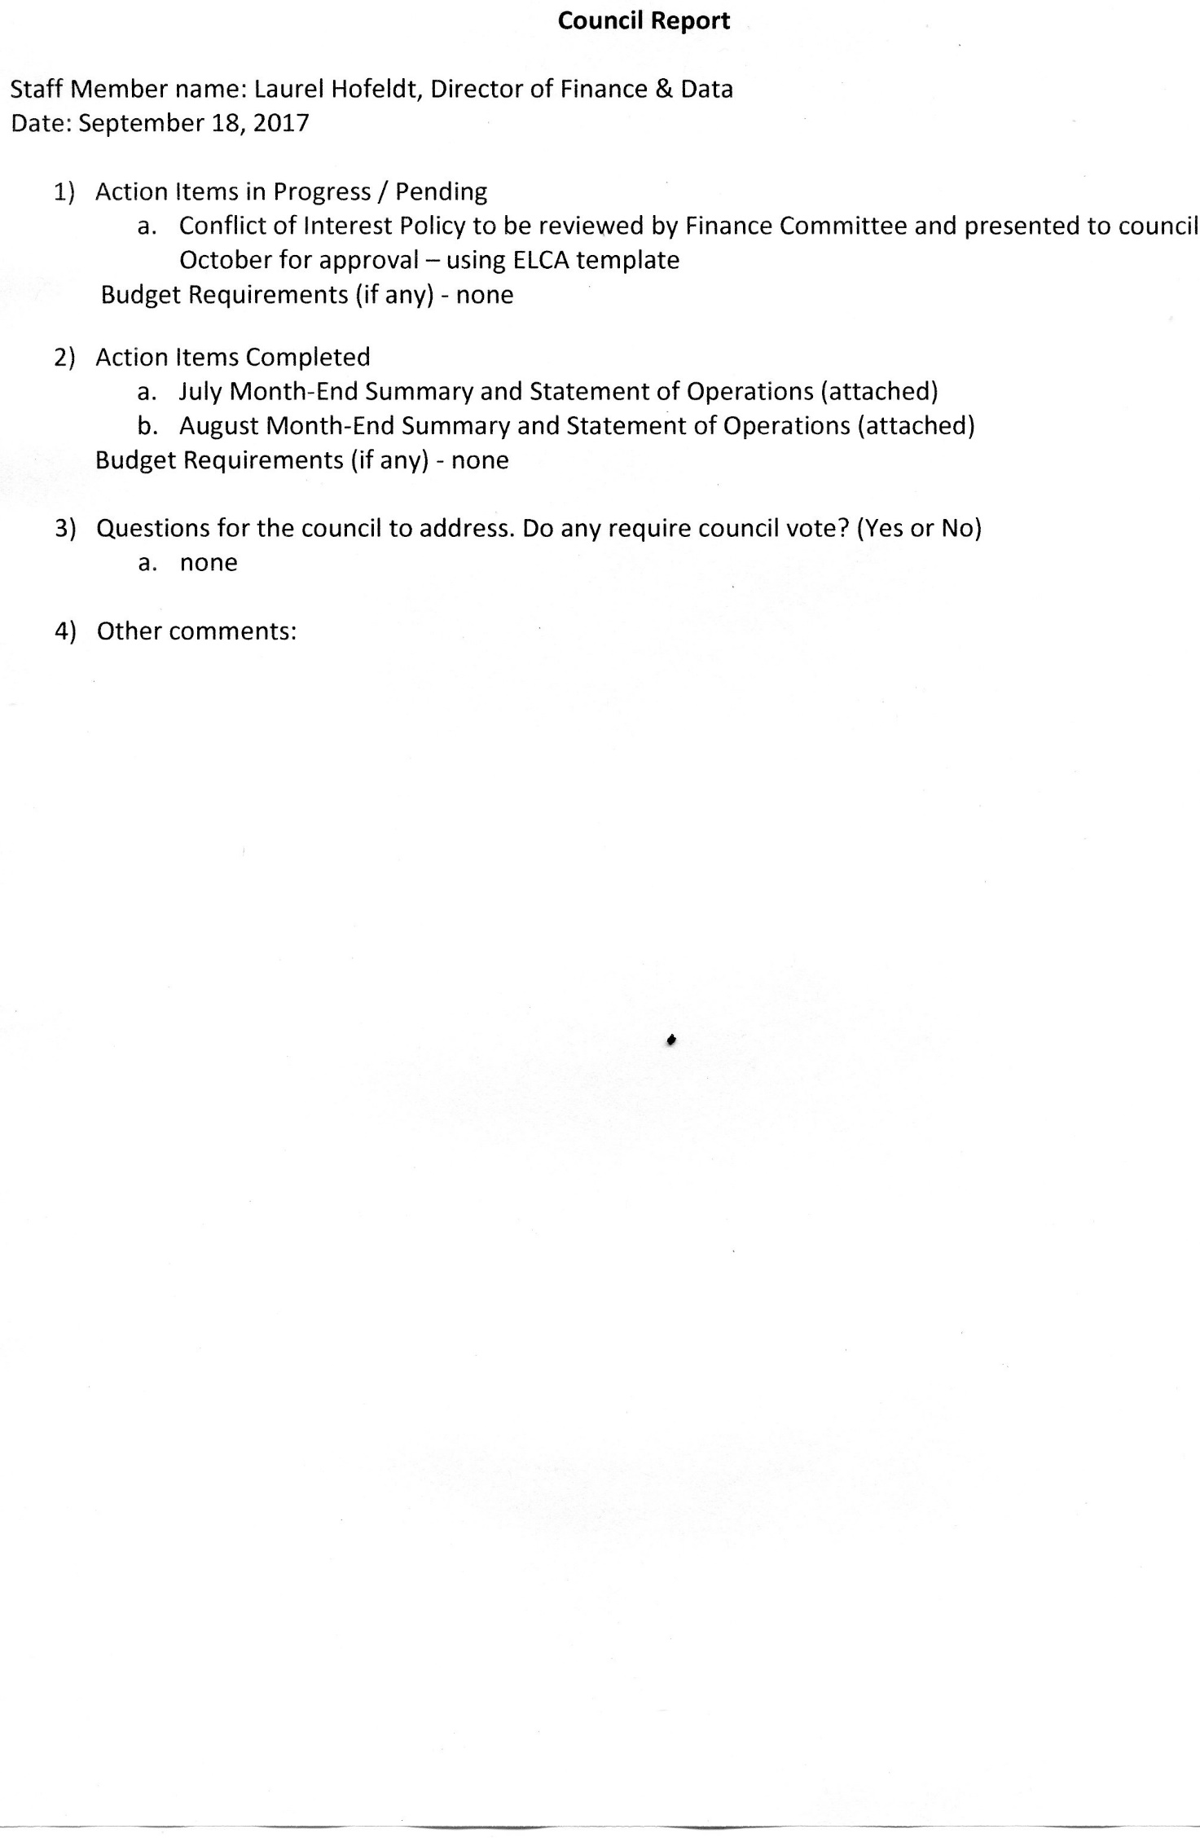
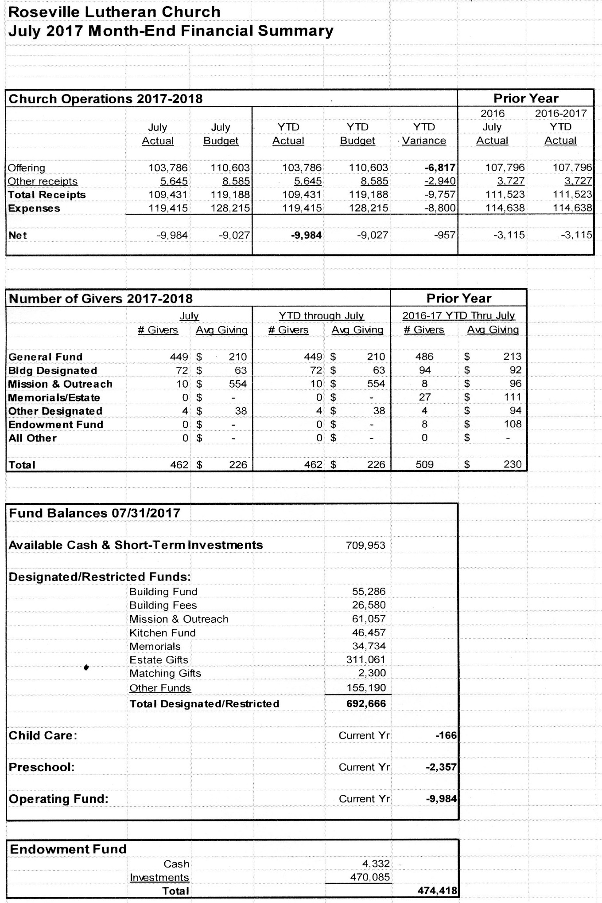
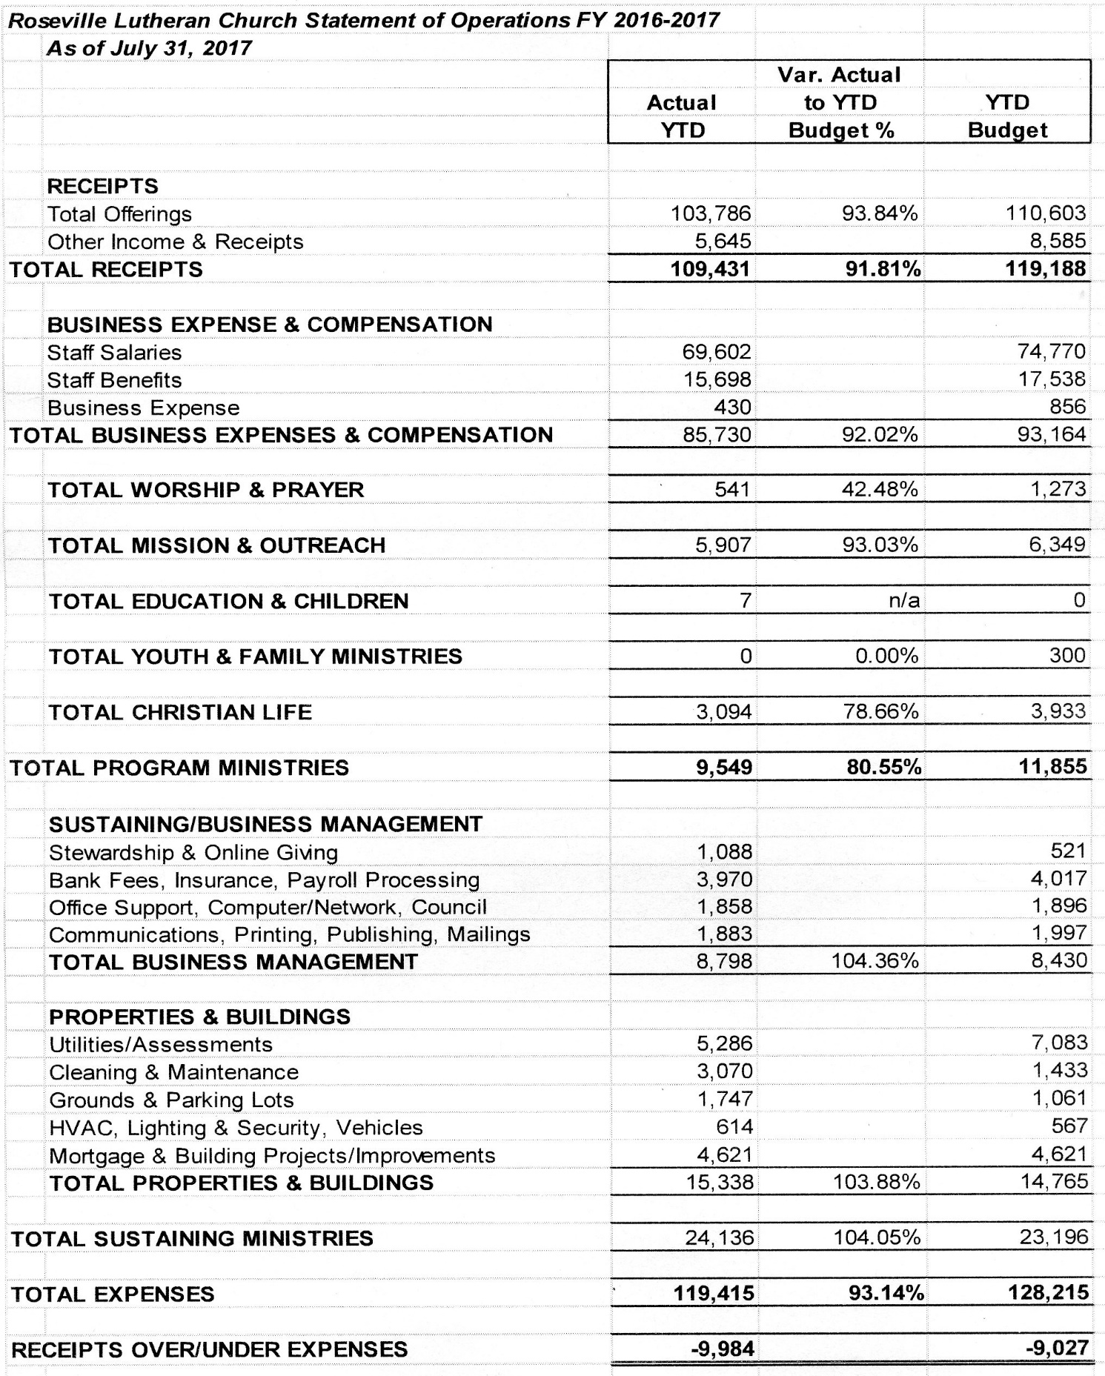

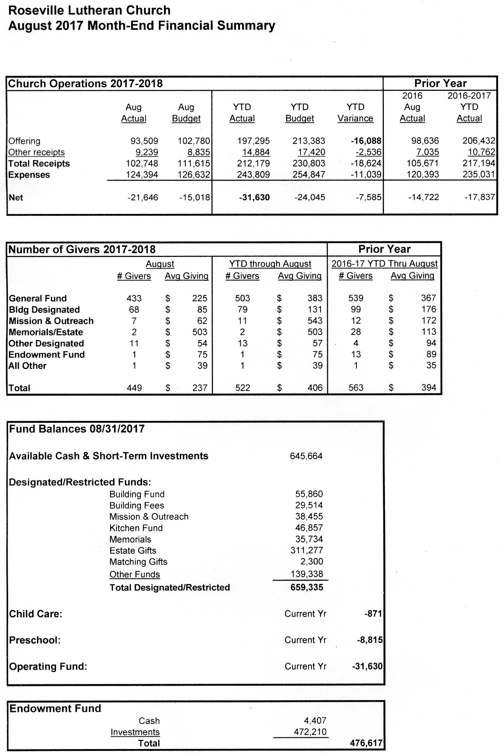
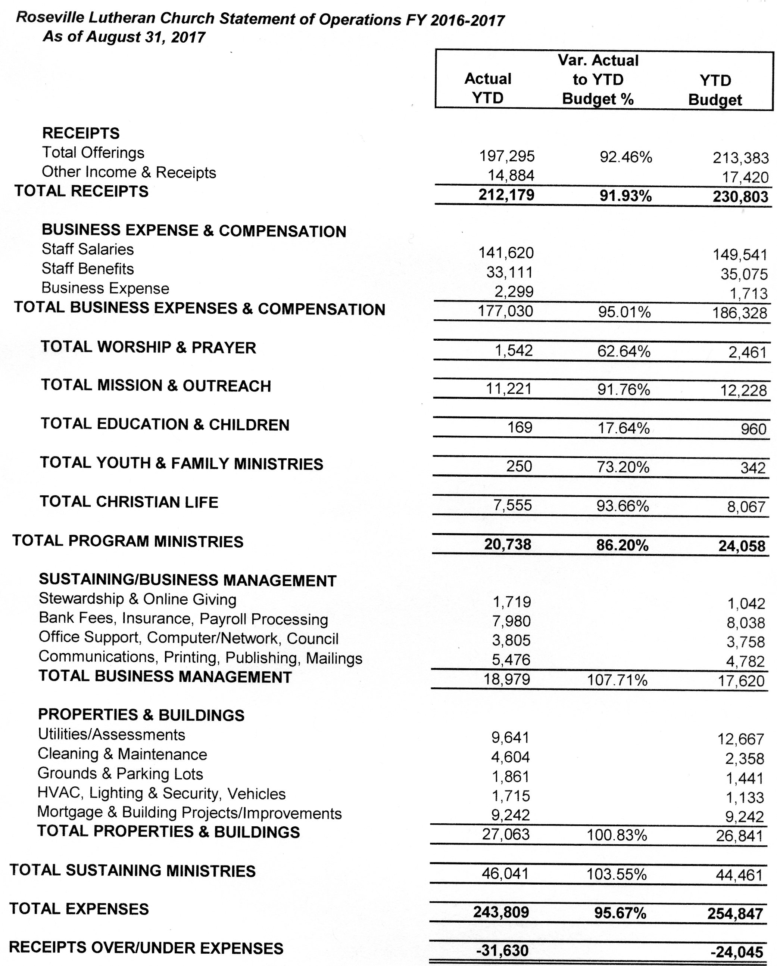

Innovations in Management – Trust in Unity sessions

Strategic Planning – Stage I:
This past fall the Strategic Planning Committee spent 6 months discussing the mission and vision of Roseville Lutheran Church and are committed to the new vision and mission statement: “Love God. Love Neighbor. A community united by grace.”
Our work, however, is not done!

Strategic Planning – Stage II:
We are excited to begin our work towards communicating and implementing this mission and vision into all areas of our ministry. This work is already beginning in some of our committees as well as our lay leadership and staff. As we begin this process is it vital that the relationship between and among leadership, staff and congregants is one built on trust and unity.
To that end, we are seeking funds to engage with Innovations in Management (http://www.innovationsinmanagement.com/) to assist us in leading a comprehensive plan or action to take RLC into the next phase of our strategic visioning process.
Please see the attached proposal. (This proposal would need to be updated to reflect current dates)
Our facilitators are Dan Haupt and Bruce Matza of Innovations in Management. They will be conducting listening sessions with people from a cross-section of the church staff, leadership and laity. Everyone not involved in a listening session will have an opportunity to share thoughts with a confidential survey.
The Executive Committee, along with David Booms and Pastor Sara Spohr, have all had the opportunity to meet with Dan Haupt and Bruce Matza from Innovations in Management and recommend bringing this to the council for council discussion / approval.

Innovations in Management

3475 Cherry Lane – Unit C, Woodbury, Minnesota 55129
651.337.2543

August 8, 2017

Pastor Lauren Wrightsman, Senior Pastor
Roseville Lutheran Church
1215 Roselawn Avenue West
Roseville, MN 55113

Dear Pastor Lauren and Members of the Church Council:

We appreciate this opportunity to propose how we may engage with the leadership and staff of Roseville Lutheran Church. We appreciate your confidence in our creation of a process that may build trust amongst leadership, staff and congregants and lead to a comprehensive plan of action to take your organization to new heights over the next several years.

Overall Objectives as Your Facilitators

As your facilitators, our objective is to create an effective engagement process that includes these elements:
- A positive, respectful and unique facilitation process
- The introduction of new methods for collaboration
- Outcomes that maximize participation
- Motivate participants to a high level of commitment to the end results
- Provide a social connection that results in greater appreciation for each other
- Develop a clear and concise implementation plan

Overview

You have taken important steps to begin a long-range plan by developing a new Mission and Vision Statement for Roseville Lutheran Church. As you completed the first phase of planning, it is critical that you maximize the trust and key relationships amongst all groups within the church. This will require a multi-faceted approach. It will be essential to reach out for one-on-one listening sessions with specific individuals as well as conduct some number of Trust and Unity Sessions to build respect and consensus between these groups. That will open the door for a dynamic and comprehensive dialogue for long-term strategic visioning and planning.

One-on-One Listening Sessions

We believe it critical to begin with one-on-one or small group “Listening Sessions” with stakeholders in Roseville Lutheran. Those people may include the Pastors, Officers and Members of the Church Council, cross section of Church Staff, Pre-School Staff, Key Volunteers, as well as any financial benefactors and past volunteer leaders who may be identified as individuals with important insights to the success and well-being of the church.

E-Mail Survey

We will also consider conducting a brief survey to Members of the Church Council and Church Staff who are not involved in the Listening Sessions. This brief survey is to determine expectations and suggested directions for the church. This will educate us to better understand the issues and opportunities facing Roseville Lutheran Church.

Trust and Unity Sessions

Upon completion of the Listening Sessions, we will coordinate with the Senior Pastor and the Council President to schedule sessions that will expand on the results of the listening sessions and begin to set the foundation for your continued strategic planning. Plan for a separate 90-minute session with the Church Council and a 2-hour session with Staff. These will be followed up with a joint “Trust and Unity” session with both Council and Staff. The agendas will be a balance of activities with small and large group discussions that address communication skills, effective meetings, promoting trust, serving your Members and advancing the Mission and Vision of Roseville Lutheran.

Storyboarding for Group Decision Making

We will use the process of Storyboarding which was developed by the Walt Disney organization. It is a very visual process for documenting discussions, encouraging participation and providing high levels of collaboration. A description of Storyboarding is enclosed with this proposal.

On-going Consultation

In addition to the Listening Sessions and Trust & Unity Sessions, you may continue to contact us as a resource for follow-up and implementation discussions. There is no additional charge for on-going telephone and email consultations.

Scope of Work

Phase I - Mission & Vision

Activity | Timeframe | Participants
You have initiated the process for developing a new Mission and Vision for the church. | January – July 2017 | Pastors, Church Council and Senior Staff.

Phase II – Trust & Unity Project

Conduct Listening Sessions  (10 to 15 sessions) | August – September 2017 | Selected Officers and Members of Church Council, Pastors, Senior Church Staff, Key Volunteers and Benefactors
Conduct E-Mail Survey | September 2016 | Council, Church or School Staff or Stakeholders not involved with the Listening Sessions
Separate sessions with Council and Staff.  Joint Trust and Unity session with Council and Staff | October 2017 | Church Staff  School Staff  Church Council  School Board  Other Key Stakeholders
Submission of Final Report to Church Leadership | At conclusion of Sessions | A written report and recommendations will be available within ten days after the Trust and Unity Sessions are completed
On-going follow-up | You may contact us as a resource for follow-up and implementation discussions | Available for the year following our engagement with you.

Fees and Expenses

We will conduct the pre-planning, phone conferences, email surveys, develop the agenda, facilitate the events and have a completed plan of action report back in your hands within a week of the event. All materials will be provided. Our honorarium for all aspects of this proposal is $9,000.

Phase III – Complete Strategic Visioning & Planning for the Future

If Roseville Lutheran would be interested in engaging us to facilitate the long-range planning and strategic visioning sessions, we will be delighted to provide a separate proposal.

Individual Leadership Coaching

Very often, one or more key individuals benefit from on-going leadership coaching. A separate proposal will be provided if this service is of value.

We thank you for this opportunity to share and participate in your vision for Roseville Lutheran Church.

Warm regards,
Bruce Dan
Bruce R. Matza Dan Haupt

Enclosed: Biographies
Description of Storyboarding

ACCEPTANCE of PROPOSAL:

On behalf of the Roseville Lutheran Church this proposal is accepted.

Name & Title ______________________________

Date _____________________

Bruce R. Matza

Bruce R. Matza brings a wealth of experience in strategic planning, staff & customer retention and customer service. He has over 35 years of experience with such prominent brands as Neiman Marcus, where he was a senior executive for 20 years. He has advised numerous organizations including Walt Disney World, Harrods of London, Marriott, Motorola, Harley Davidson, Mandalay Bay Hotel & Casino, National Retail Federation, National Restaurant Association, Austin, Texas Board of REALTORS®, American Society of Association Executives, US Chamber of Commerce, United Way Worldwide and many others.

He is author and creator of Becoming a Customer Service Star, initially designed for Walt Disney World. It is in a 3rd edition published by HRD Quarterly and to date has sold over 250,000 copies to organizations interested in the enhancement of their customer satisfaction initiatives.

Bruce is a well-known speaker, seminar leader and facilitator. He serves as a strategic planning facilitator and advisor. He is also a leadership mentor to physicians and executives across the country.

Bruce served honorably as an officer in the U.S. Air force and has been featured in many articles and stories in addition to being a guest on The NBC Today Show.

Dan Haupt

Dan brings over 35 years of experience working in large and small organizations, for profit and nonprofit, and in Christian ministries. Dan has worked for churches and non-profit organizations for in executive positions – in both administrative and ministry capacities. He is currently Director of Operations for the Alley Church in Cottage Grove, Minnesota.

In addition, Dan recently started a life coaching business. Dan has a passion for helping organizations and individuals to realize their potential. Over the years, he encountered many people who are "stuck" in some area of their life. Dan has a passion to walk beside them, and help them gain clarity so they can move forward.

Dan has been married to his best friend, Renee, for over 30 years. They have three children and four grandchildren. They provide great joy in life! Dan loves life and sees it as an adventure. Part of what makes life an adventure is listening to people share bits and pieces of their life story, which is a great benefit to being a life coach and advocate.

In his spare time, Dan enjoys traveling, golfing, and reading.

The Art of Storyboarding for Group Problem Solving

Storyboarding Description

Become an improved leader by remembering what you learned in 3rd grade!

In third grade you began working with fractions, got pleasure by drawing pictures, and were encouraged to participate as part of a group. Now find out how all of these early experiences can make you a better leader.

This is a workshop process that will explore the many applications of Storyboarding, one of the fastest growing problem solving and team building techniques available to today’s leaders. You will learn how to conduct better meetings, more effective coaching sessions, and dynamic group problem solving situations.

Here is a collection of total quality management tools all rolled into one process. It’s easy to learn how to take this skill home and be an expert facilitator with your organization overnight. Audiences rave about the interactive process of the Storyboard process and the real life applications that are immediately available to use. Plan to be involved in real problems, actively participate with a group and take home an armload of new ideas to get things done.

Bruce Matza, principal of Innovations in Management, will facilitate this entertaining and high impact process. He is highly regarded as a speaker, seminar leader, publisher of customer satisfaction materials and has appeared on the NBC Today Show.

