Date: August 10, 2017
- Call to Order Sara Mohn calls the meeting to order at 7:05pm
- Devotional / Shared Prayer Sara Mohn leads Council in prayer
- Establish a Quorum So established
  - Members present: Sara Mohn, Jeff Johnson, John Shardlow, Mike Dolan, Vanessa Anderson, Jake Von De Linde, Darci Bontrager, Jessica Henry, Beth Jacobson, Joe Zeigler
  - Members absent: Keith Gilbert, Georgia Nygaard, Tom Lund
  - Others present: Pastor Lauren Wrightsman, Pastor Sara Spohr, Dave Booms
- Approval of Agenda So moved and approved
- Approve Previous Months Minutes June minutes were reviewed, and a motion was called for approval. The motion was seconded and approved. In addition, the May Council minutes were looked at again regarding Endowment grants. A motion was called for approval, seconded and they were approved.
- Special Appeals request: Michael Jordan The appeal was retracted.
- Monthly Reports
  - Finance: Lauren
The finance report is attached from Laurel Hofeldt. Pastor Lauren discussed several highlights. The congregation was very generous in the last month or two of the 2016-17 fiscal year. A projected $70K budget shortfall was turned to a $3K surplus to finish the fiscal year June 30. Funds from M/O and other gifts were not needed to close the gap. Many members of Council expressed their gratitude and thanks for the phenomenal response. However, our task for this fiscal year is to not need to make up a shortfall at the end of the year. Several clarifications were discussed in the figures, followed by a motion to accept the year end financials. This was seconded and approved.
  - Staff
      - Pastors
        - Senior Pastor

Pastor Lauren outlined a new policy where four staff members (Pastor’s Lauren and Sara, Dave Booms and Laurel Hofeldt) will supply monthly reports to Council. In future months they will be combined into one document. Pastor Lauren’s report is attached. The most important issues in reports will be discussed at Council. Pastor Lauren related ongoing discussions about worship schedules as it relates to the new strategic plan, weekday and weekend worship, and other weekend activities. Council expressed interest in a task force to look at worship with Pastor Lauren. A motion was presented as such and approved. Mission and outreach has already began looking at their charge as it relates to the strategic plan. Finally, Pastor Lauren expressed some reservations about access of financials online (i.e. open to all). A consensus was agreed to by Council that financials will not be online but available on request from the office or by mail.

        - Associate Pastor
Pastor Sara’s report is attached. She noted the report and also requested Council consider attending Abby Matter’s Deacon ceremony. A request was made to approve hospitality for the event. Council approve by acclamation.
      - Church Administrator

The monthly report by Dave Booms is attached. The report outlines 70-80 groups which have used space at RLC in the past year, leading to a number of events. Roseville Lutheran has hosted a number of funerals for members and non-members alike. Dave discussed engagement by RLC staff Steve and Connie in new activities as well as others done in the past. New signage and banners are in place around RLC about the upcoming 75th anniversary. Lawn signs are available for members to post at home about RLC. Management system and AV upgrades are in process, with more to follow as we near the anniversary celebration. Additional funds may be required. Connie is beginning to prep for fall activities. Finally, several projects have taken place around the old church including tree trimming and removal, and stained glass repairs. A memorial gift is available for design projects like information bins in pews. New Council members will get packets in the next month which will detail Council related information.

      - Other

  - Committee Updates
    - Mission & Outreach- Darcy

M/O will delay meeting with Council until next month to allow for more discussion. 1010 hour discussions were well attended and liked. Wednesday evening discussions are a possibility. Future planning may take place with “Do good Roseville”.

    - Stewardship- Keith No report, did not meet in July.

    - Children-Joe The committee is meeting on Monday August 14. A revised charter has been discussed and will be available for approval.

    - Youth & Family- Jake Summer camps were well attended and successful. Our Slovak student guests have returned home.

    - Adult Ed- Georgia No report.

    - Christian Life- Vanessa No report.

    - Nominating- Joe Joe requested the nominating committee follow up with candidates after the annual meeting election with phone calls. Welcome those elected and encourage those not elected to volunteer elsewhere.

    - Task Force Updates

      - Strategic Planning:

        - Worship/music/Wednesday evening committee Nothing further noted.

        - Facilities and maintenance task force Maintenance due on roof and drainage areas. Opportunity for a wider look at facilities. A motion to delegate a facilities task force was made and seconded; the motion was approved. The task force will look at facilities and give an initial report next month. Some maintenance is needed soon but any actions should keep in mind future improvements (i.e. solar panels, etc.).

      - 75th Anniversary Pastor Lauren said plans are continuing for the celebration.

- Continuing Business Nothing further noted.
- New Business Nothing further noted.
  - Mission and Outreach task force formation No further discussions.
  - Annual Meeting No further discussions.
  - Upcoming dates
    - Staff appreciation lunch: August 15th 11:00-1:00 at Como Picnic Grounds. Note time change. Stop by if you can to say thank you.
    - August Potluck for incoming and outgoing council member August 24th, 6:00 at Sara Mohn and Bill Schultz’s home. 3385 Snelling Ave. Spouses/Partners invited! Bring a side to share.
- Review Decisions / Action Items No further action noted.

- Adjournment A motion to adjourn was made, seconded and approved.
- Closing Prayer

Respectfully submitted
Mike Dolan
Vice President Elect

Attachments

Council Report
Senior Pastor, Lauren Wrightsman
August, 2017

- Action Items in Progress / Pending

  - 75th Anniversary celebration: Continued work with this team is ongoing. Pastor Sara, John Helgen and myself have worked through a mock-up of the 75th anniversary worship on November 19th.

  - Continued work with Stewardship to address the campaign going into the fall

  - Direction for the Strategic Planning: I would like to discuss next steps with Council including:

      - Worship: I would like to pull together a team of individuals to come together to discuss our worship and music offerings. This is certainly part of the Strategic Planning – however, it may be helpful to hear from a group of individuals. I am specifically thinking about our 11:00 “contemporary” music. Both John Helgen and Sara are also eager to begin this discussion.

We must also consider our summer worship schedule. This was the first summer we decreased our summer worship. We have certainly seen a decrease in attendees during the summer.

What follows is a graph showing:
- A: 2016 summer worship attendance
- B: 2017 summer worship attendance
- C: % difference in worship attendance between ‘16 and ‘17
- D: 2016 worship attendance for 5:00 and 8:00 ONLY
- E: 2016 worship attendance for 5:00 and 8:00 as a percentage of total 2016 worship
  - I have also made notation of two special events we had during 2016 which increased worship participation. We did not have any of these larger events in worship this summer.

A B C D E

Week 2016 2017 % diff ’16 5/8 att = % worship total
June #1 560 399 - 33.6% 147 26.25%
June #2 492 373 - 27.5% 101 20.53&
June #3 619 (camp) 375 - 49.1% 125 20.19%
June #4 503 527 - 4.7% 90 17.89%

July #1 411 326 - 23.1% 125 30.4%
July #2 540 491 - 9.5% 117 21.7%
July #3 501 446 - 11.6 % 100 19.9%
July #4 683 (drums) 380 - 57.0% 128 18.74%
July #5 472 329 - 35.7% 110 23.30%

Average median decrease: - 27.5%

Average median of 2016 5:00 and 8:00 members: 20.53%

      - Wednesday evening education schedule and educational offerings
It would be beneficial to re-evalulate our Wednesday evening opportunities while we consider our weekend worship. Some members wondered if it would be possible to do a mid-week summer worship. I think this needs to be considered, however, it can’t be considered without also considering a mid-week worship throughout the year. This takes time to consider – and if not planned well it will most certainly fail. If we want it to succeed it must be well thought out and implemented.

Budget Requirements (if any)
None

- Action Items Completed

Budget Requirements (if any): None

- Questions for the council to address. Do any require council vote? (Yes or No)

Financial Annual update: APPROVAL: Laurel will be providing the 2016-2017 annual financials and I will facilitate the conversation. This will need to be approved by council at the July meeting

Financials online: I would like to have a discussion of the financials being online. This is not a very common practice among churches. We are aware it needs to be made available. At previous churches we would invite members to pick up a copy at the church office or call / email to request one being sent to them.

- Other comments
  - Laurel Hofeldt will be on vacation. I met with her this week to talk through the financials. I will be happy to lead this conversation at council this month.
  - We had a wonderful family vacation in Colorado and successfully sent Carolyn on her way for her year abroad in Sweden!
  - Thank you for organizing the staff appreciation event. It will be good for the staff to have time to relax and enjoy some time together off-site.

Roseville Lutheran Church
June 2017 Month-End Financial Summary

Church Operations 2016-2017 |  |  |  |  |  |  |  |  | Prior Year
2016 |  |  |  |  |  |  |  |  | 2015-2016
June |  | June |  |  | YTD |  |  | YTD |  | YTD |  |  | June |  |  | YTD
Actual |  | Budget |  |  | Actual |  |  | Budget |  | Variance |  |  | Actual |  |  | Actual
Offering | 126,612 |  |  | 101,766 |  |  | 1,508,512 |  | 1,516,000 |  | -7,488 |  |  | 87,549 |  |  | 1,357,183
Other receipts | 3,949 |  |  | 34,820 |  |  | 81,487 |  | 124,000 |  | -42,513 |  |  | 25,801 |  |  | 121,111
Total Receipts | 130,562 |  |  | 136,586 |  |  | 1,589,999 |  | 1,640,000 |  | -50,001 |  |  | 113,351 |  |  | 1,478,294
Expenses | 120,572 |  |  | 146,326 |  |  | 1,586,433 |  | 1,640,000 |  | -53,567 |  |  | 133,255 |  |  | 1,489,721
Net | 9,989 |  |  | -9,740 |  |  | 3,566 |  | 0 |  | 3,566 |  |  | -19,904 |  |  | -11,427
Prior Year |  |  |  |  |  |  |  |  | Number of Givers 2016-2017
YTD through June |  |  |  |  |  | 2015-16 YTD Thru June |  |  |  |  |  | June
# Givers |  |  | Avg Giving |  |  | # Givers |  |  | Avg Giving |  |  | # Givers |  |  | Avg Giving
General Fund |  | 421 |  |  | 223$ |  |  | 856 |  | 1,581$ |  |  | 911 |  |  | 1,523$
Bldg Designated |  | 67 |  |  | 63$ |  |  | 157 |  | 545$ |  |  | 166 |  |  | 487$
Sow>Grow>Give |  | 75 |  |  | 231$ |  |  | 206 |  | 365$ |  |  | 0 |  |  | -$
Vibrant Faith |  | 0 |  |  | -$ |  |  | 0 |  | -$ |  |  | 37 |  |  | 343$
Mission & Outreach |  | 10 |  |  | 104$ |  |  | 203 |  | 273$ |  |  | 193 |  |  | 318$
Memorials/Estate |  | 21 |  |  | 9,324$ |  |  | 75 |  | 4,729$ |  |  | 114 |  |  | 880$
Other Designated |  | 1 |  |  | 20$ |  |  | 245 |  | 237$ |  |  | 217 |  |  | 139$
EF/Love Lights |  | 23 |  |  | 67$ |  |  | 132 |  | 66$ |  |  | 80 |  |  | 64$
All Other |  | 0 |  |  | -$ |  |  | 5 |  | 280$ |  |  | 13 |  |  | 286$
Total |  | 461 |  |  | 686$ |  |  | 944 |  | 2,110$ |  |  | 974 |  |  | 1,726$
Fund Balances 06/30/2017
Available Cash & Short-Term Investments |  |  |  |  |  |  |  |  | 728,632
Designated/Restricted Funds:
Building Fund |  |  |  |  |  |  |  |  | 56,645
Building Fees |  |  |  |  |  |  |  |  | 26,000
Mission & Outreach |  |  |  |  |  |  |  |  | 49,803
Kitchen Fund |  |  |  |  |  |  |  |  | 46,228
Memorials |  |  |  |  |  |  |  |  | 34,734
Estate Gifts |  |  |  |  |  |  |  |  | 311,459
Matching Gifts |  |  |  |  |  |  |  |  | 2,300
Other Funds |  |  |  |  |  |  |  |  | 171,582
Total Designated/Restricted |  |  |  |  |  |  |  |  | 698,752
Child Care: |  |  |  |  |  | Current Yr |  |  |  |  |  | 25,195
Preschool: |  |  |  |  |  | Current Yr |  |  |  |  |  | 1,114
Operating Fund: |  |  |  |  |  | Current Yr |  |  |  |  |  | 3,566
Endowment Fund
Cash |  |  |  |  |  |  |  |  | 4,332
Investments |  |  |  |  |  |  |  |  | 464,136
Total |  |  |  |  |  |  |  |  | 468,469

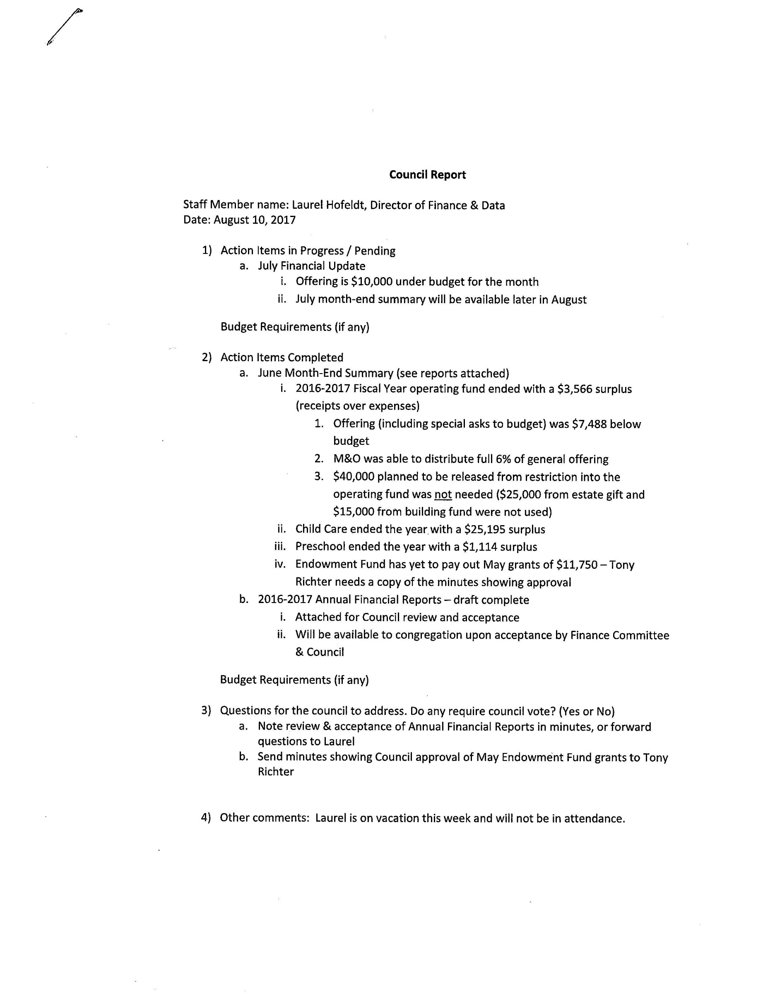
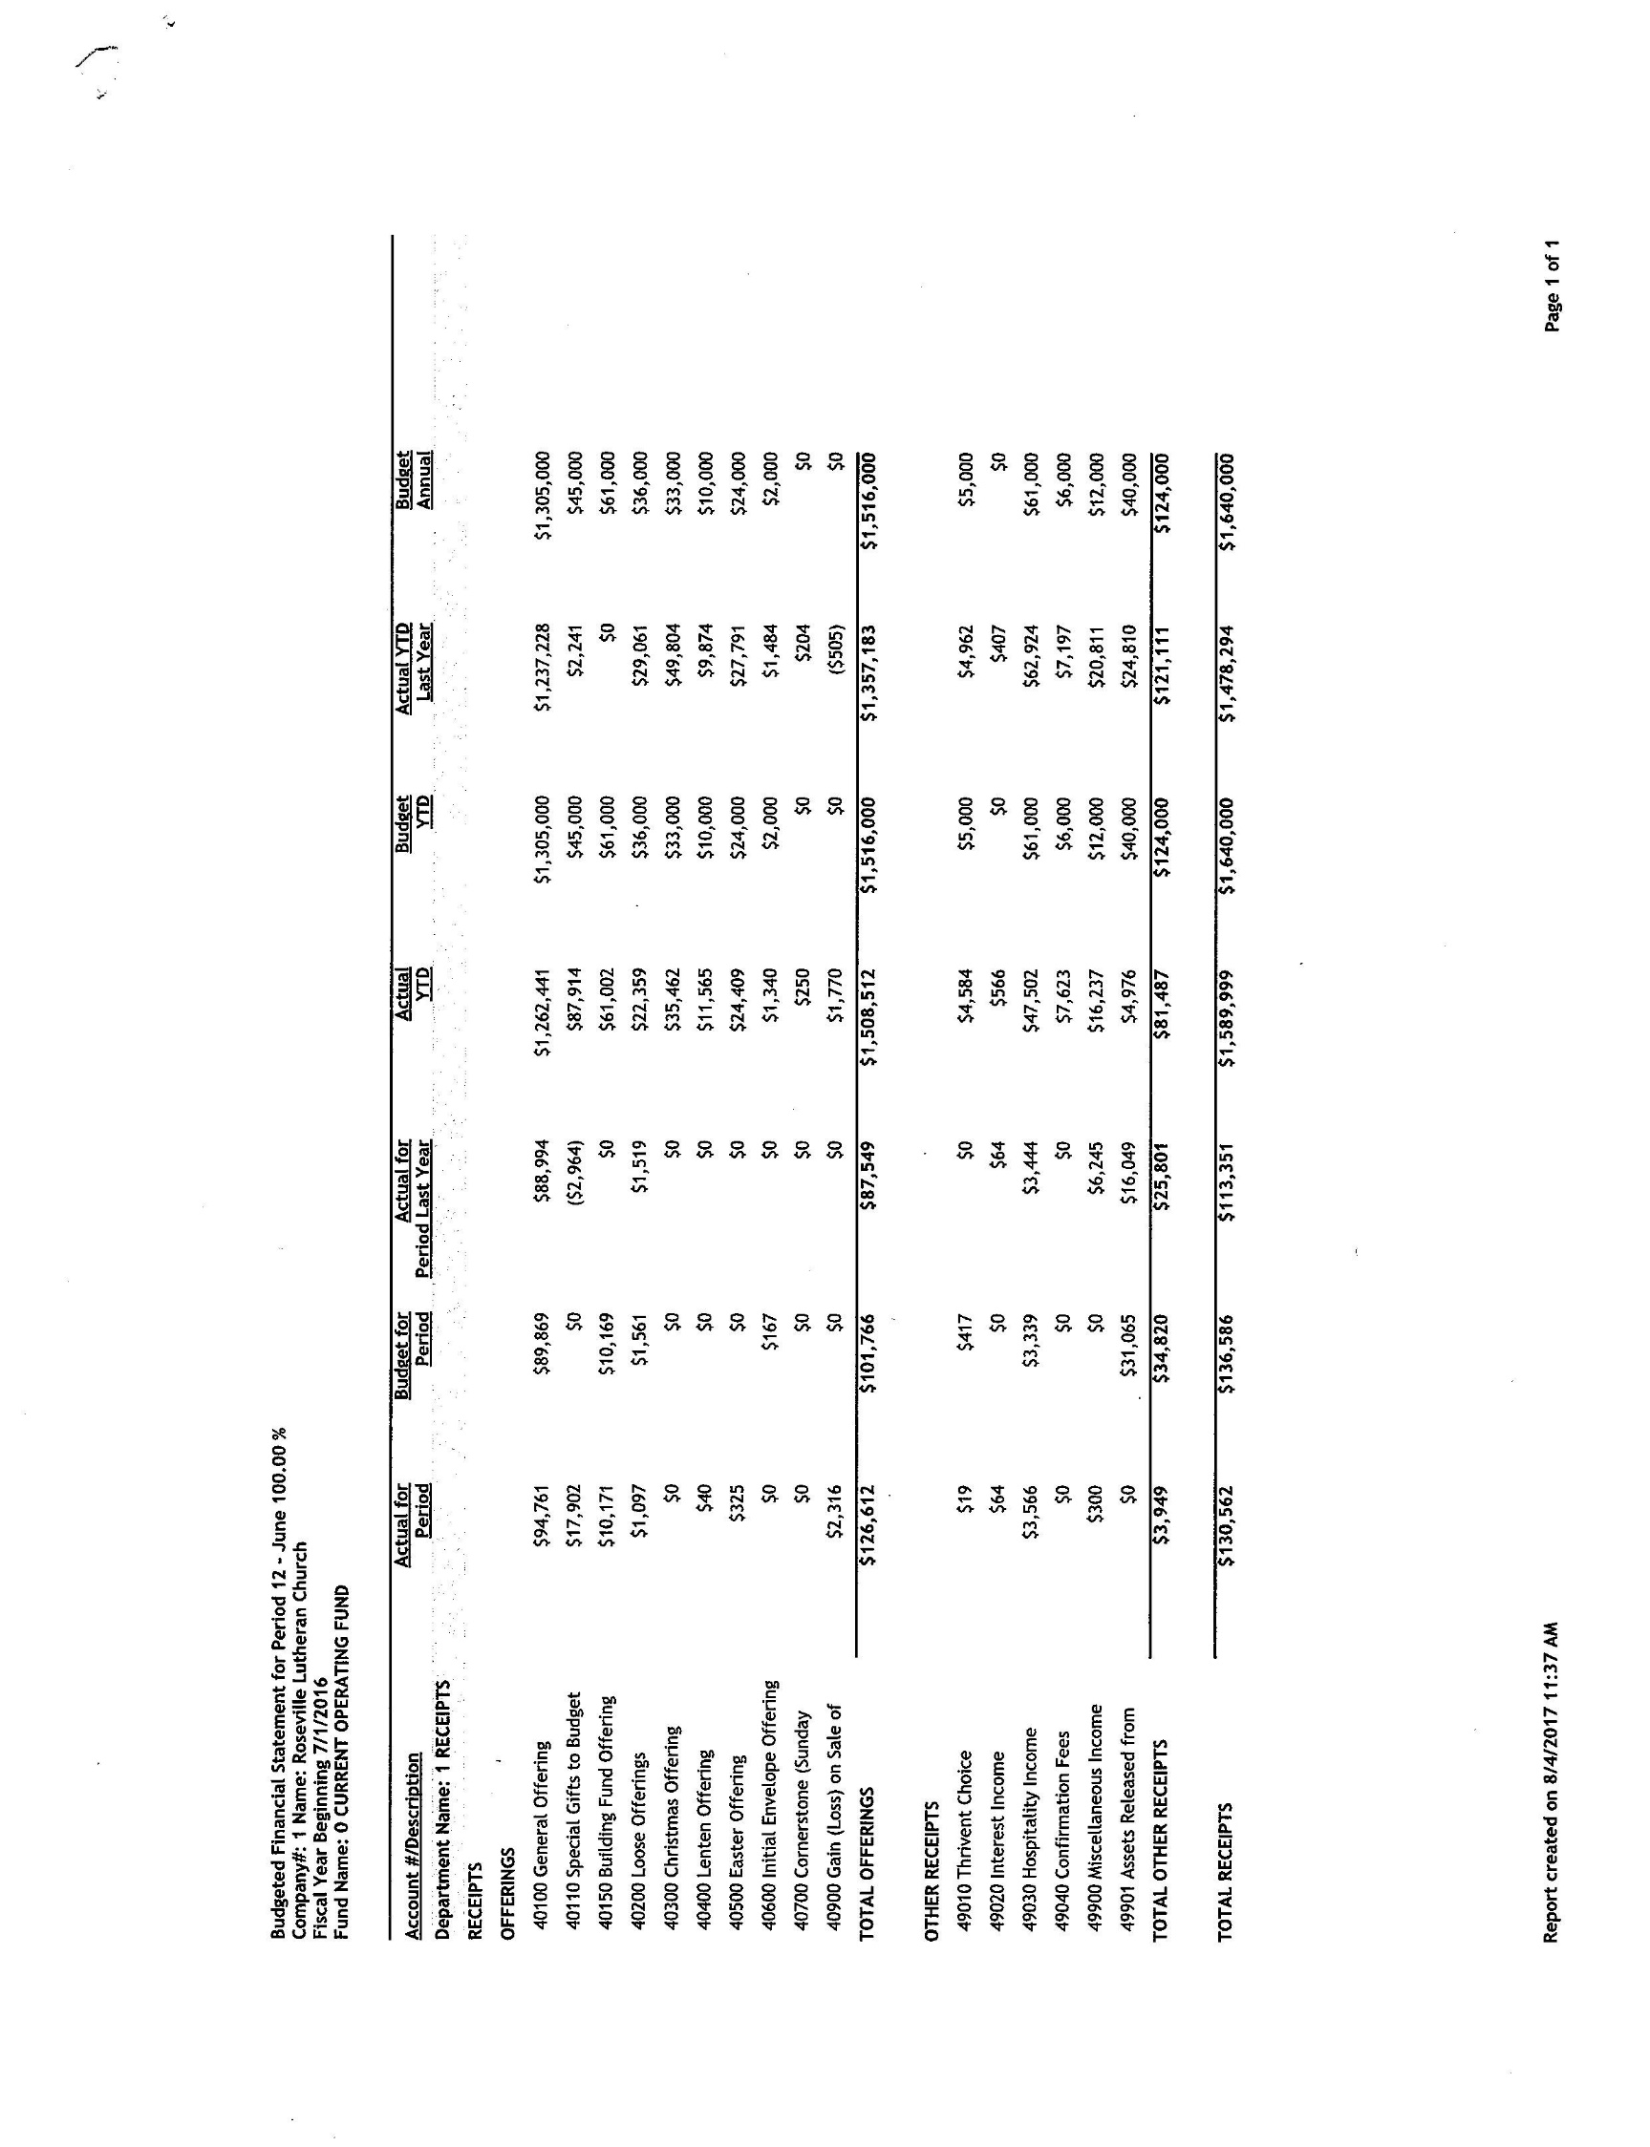
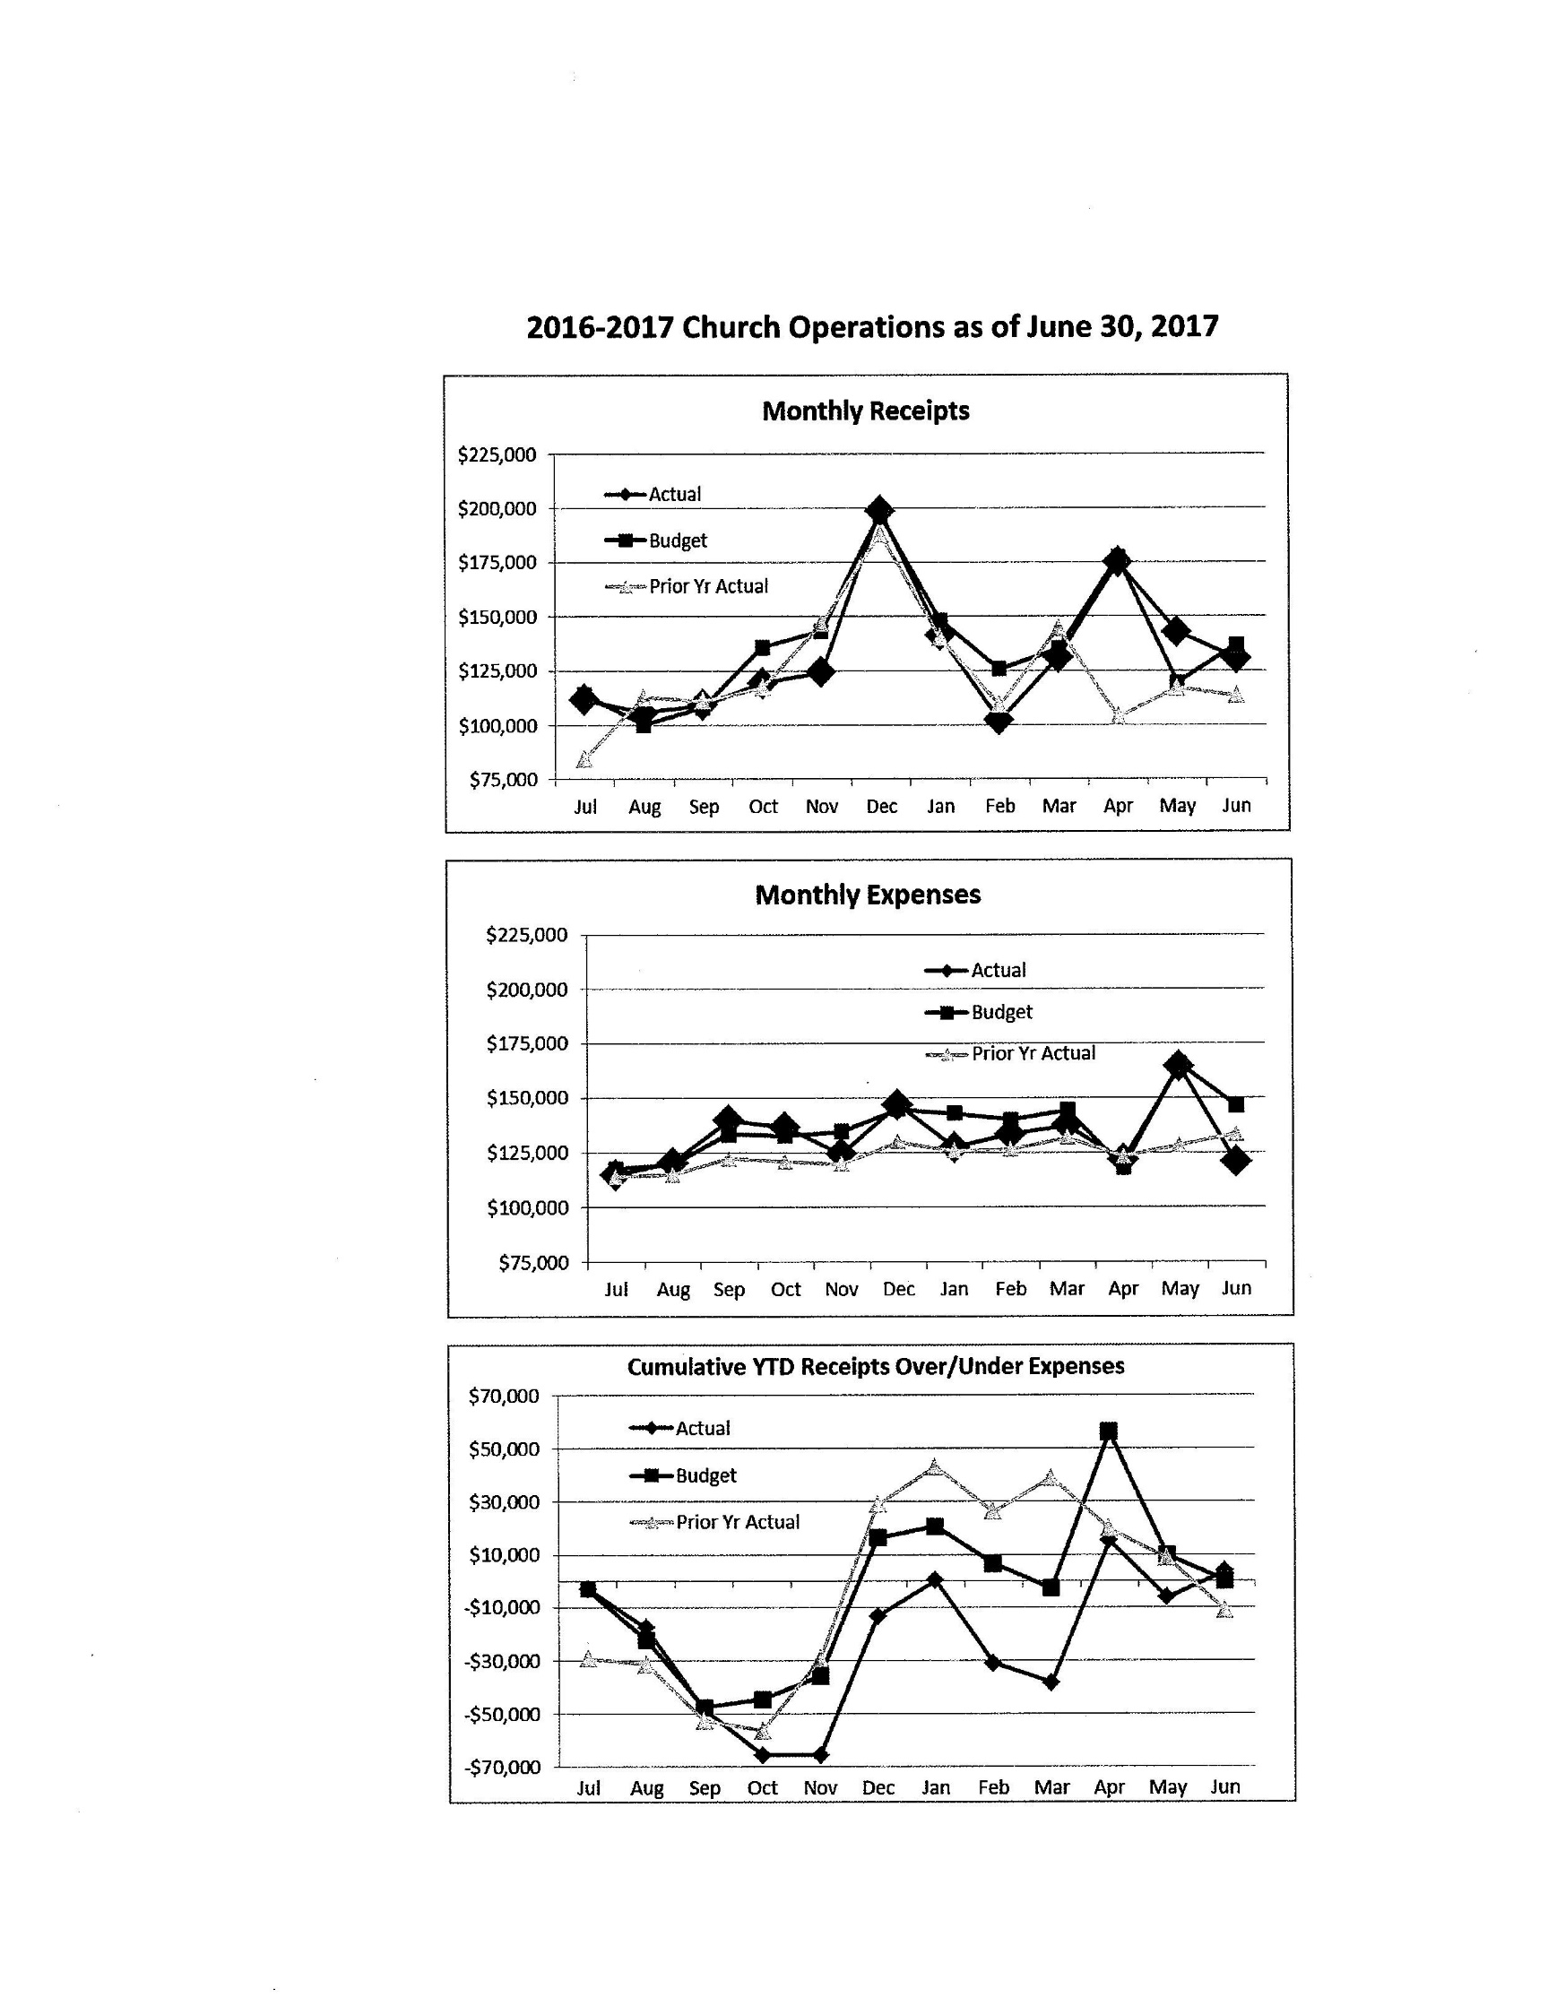
Council Report

Staff Member name: Pastor Sara Spohr

Date: August 2017

1) Action Items in Progress / Pending
• Mission and Outreach Taskforce. I am working with Dave Richter and a group of 8
other people to think carefully about Roseville Lutheran’s Mission and Outreach
efforts. This task force is using our new vision and mission document as a central
and guiding document for our work together. Our first meeting is this week,
August 9.
• Unity Project for Fall. I am working with the Creative Team to install a temporary
piece of art in our Commons that will attempt to highlight the different
backgrounds and life experiences of our members while drawing these differences
into beautiful unity. Will be in progress in the commons starting September 17.
• Fall Children, Youth and Family Programing. Our staff have now completed 7
summer trips, camps, and programs and have turned their efforts toward Fall
programing. They are working carefully to set schedules, plan retreats, recruit
and train leaders, and find/write curriculum that is engaging, inspirational and
teaches the faith well.
• I am looking ahead to Lent and pulling together worship themes and texts that will
work well for both worship and for our confirmation small group conversations.
The adult ed team has also asked me to work on a Lenten Devotional booklet, so I
hope to be able to add this to our church wide study.
Budget Requirements (if any)
2) Action Items Completed
• I am following up with CYF staff on summer programming. Trips are done and we
are celebrating these successful programs. Worship on August 20 will highlight this
summer celebration.
• I’ve been working with the stewardship team to incorporate some giving language
into our fall registration forms. This has been completed. The language and the ask
are very appropriate and I’m hopeful this will be another seed planted encouraging
people to think about generosity.
Budget Requirements (if any)
3) Questions for the council to address. Do any require council vote? (Yes or No)
• I have nothing that needs council action at this time.
4) Other comments
•

Staff Member name: Dave Booms-Church Administrator

Date: 8/08/17

- Action Items in Progress / Pending
  - Building & Grounds
    - Rentals
      - New customers
        - MN Adopt
        - World Encounter
        - Chinese Dance Camp
        - Luther College Alumni
        - Bulgarian Cultural Center
      - Repeat Customers
        - Ollie
        - Concerts
        - ADK
        - MN Federation for the Blind
    - Projects
      - Security upgrades
      - Reception area “make-over”
      - Carpet cleaning Pre-school
      - Pew card holder
      - Caulk & paint north end of the Worship Center
      - Volleyball Court maintenance
      - Roof Repair
    - 75th anniversary prep
      - Commons: art install
      - Stain glass in ’48 bldg
      - Artifact display
      - Banner install

  - Communication
    - Related to the 75th anniversary
      - Magazine
      - Signage
      - Videos
      - Other displays
      - 75th Anniversary - Gala Worship Nov. 19

    - Upcoming Projects
      - Fall Kick-off (Rally Sunday, etc.)
      - Stewardship Materials, design, mailing, web, etc.
      - Advent, Christmas Eve
    - Training new Communications Specialist

  - Shelby
    - Staff Training
    - Calendar
      - Manual to Automated
  - Audio/Visual refit & repair
    - New Amp for Commons
    - Re wiring from VGA to HDMI
  - Manual revision
    - Employee
    - Wedding
  - Funerals Jun-July-Aug
    - Two Members
    - Two Friends of RLC
    - Two outside
  - Hospitality
    - Prep
      - 75th
      - Celebration Sunday
      - Prime time
      - Vets Day
      - Bible Study
      - Luther Connections
      - Kitchen license
      - Cold calling for Senior Activities & other rentals
1>Budget Requirements (if any)
- If the A/V needs exceed the current 2017/18
- If Anniversary costs exceed current budget
- Action Items Completed
  - Communication
    - 75th anniversary
      - Pens
      - Some banners
    - Other
      - Annual Report
      - Special Mission/Vision/Values brochure
      - Hired new Communications Specialist
  - Building & Grounds
    - Boy Scout project _ North Berm
    - Projects
      - Reception area - painted
      - Class room prep
      - Activity Center repairs
      - Storage area clean out
      - LL class rooms painted
      - Asphalt repair
      - Parking Lot clean & stripe
      - Landscape
      - Tree trim
    - 75th anniversary prep
      - Bell tower trim painting
      - Some banners installed

2>Budget Requirements (if any)
- Questions for the council to address. Do any require council vote? (Yes or No)

None for August.

- Other comments
We’re currently prepping the Council guidebook for 17/18. I’m requesting 15 min in Sept meeting for basics and 30 min in Oct for a “state of the departments” reports.

