Roseville Lutheran Church

Council meeting minutes: 1-19-2017

Members present: DarcI Bontrager, Georgia Nygaard, John Shardlow, Keith Gilbert, Vanessa Anderson, Joe Zeigler

Members absent: Sara Mohn, Jeff Johnson, Jake Von De Linde

Others present: Pastor Lauren Wrightsman, Pastor Sara Spohr, Dave Booms, Laurel Hofeldt

Call to order: 7:00 pm

Opening prayer: Pastor Wrightsman

Financial report: Laurel provided a financial update. See attached.

Vanessa made a motion to pay for audit expenses out of the estate gift balance. The
motion was seconded, motion passed.

The most notable take-away from the report is that there is an anticipated $80,000 needed to balance the budget for this year, assuming that the monthly offerings meet budget. It could be another $25,000 if offerings come in under budget.

Minutes: The minutes from the 11-27-2016 and 12-15-2016 council meetings were approved with the following changes: Sara Spohr was present at the 11-27 meeting, Michael Jordan wasn’t present at the 12-15 meeting. Joe moved approval as
changed, Georgia seconded, motion passed.

Pastor reports:

Sara reminded council that prior to the March 16 council meeting she would like
council members to meet with confirmation students at 6:00 pm. She is working on Abby’s “rostered leader” position.
Lauren reported that Sue Menier is out for 6 weeks due to a broken kneecap.

Lauren gave a recap of the 1-17-2017 Stewardship meeting. Stewardship is working on efforts to increase the donor base with sustainers. One effort is directed towards parents of K-12 youth, encouraging them to pledge $10/month, and their donation will be matched up to a total of $10,000. A second effort will be directed towards the last 5 years of new members. However, these efforts likely won’t relieve the immediate budget problem before us. Stewardship has discussed this also. There is some concern about weariness around repeated asks to those who already give regularly. One way to mitigate this is to keep active givers informed with quarterly conversations with council in the coming months during 10:10. This provides

people the opportunity to ask questions in advance of the annual meeting. John suggested inviting stewardship to the next council meeting.

Lauren reported that Julie Hanson has requested a pay increase for Tammy Heiple. She works on average 25 hours/week in the nursery and is paid hourly. She has worked 7 years at the same rate. Julie is asking for a $2.50/hour increase. This increase would cost about $3000 more/year. It was pointed out that Parents’ Morning Out is a fee-based service. Discussion ensued about whether PMO fees should go up to cover a pay increase. John tabled a decision on the increase since Sara and Jeff were not present.

Ministry team updates:

Nominating: Joe reported on a proposed change to the nominating committee charter, to add language to try to achieve diversity. They are starting a campaign to try to generate interest from people to serve on committees.

Finance: No report

Youth & Family: Darci reported that they had a retreat this weekend to plan the youth service which will be 2-12-2017.

Life Ministry: Vanessa reported on upcoming events: Hoppin Hopper, Rise Up O Men, Swing Dancing, a Pottery event, and a progressive dinner, all happening before May.

Adult Education: Georgia reported on Adult Education activities. See attached report.

Childrens Ministry: No report

Mission and Outreach: Darci reported that they are preparing for Project Home, and the Bridging and Dresser build. She also reported on the upcoming reading circles sponsored by My Neighbors and Me, as this falls under M&O as well as Adult Education.

Staff update

Dave reported that the kitchen cabinetry is almost finished. There is still an entryway that has to be finished off, then the kitchen project is done. An open house is scheduled for 4/23.

Dave showed a master plan for carpet created by Station 19, and discussed options for proceeding with this the carpet project in whole or in part. The entire project was sent out for 3 bids, and only 2 were returned, as the third vendor declined.

After much discussion about the bids and possible sources of project funds, council agreed that:

• We want to finish this carpet project right

• That we want to do the entire project if at all possible

• That we should seek a third bid, even though this likely will mean delaying completion of the project until possibly after confirmation.

Council was reminded of the 2-12-2017 leadership retreat, 1-4 pm, no lunch

There was brief discussion about the planning for the 75th anniversary celebration

Strategic and future planning: John reported about the activities of this working group.

Meeting adjourned: 8:24 pm.

Finance Update for Council January 19, 2016

• Give to the Max 2016 Final Totals:
o Preschool donations
§ Total (30 donors) $1,080.00
§ Less fees (1%) ($10.34)
§ Net Received $1,069.66
o RLC donations
§ | Total (46 donors/50 gifts) | $7,520.00
§ | Less fees (2%) | ($140.06)
§ | Net Received | $7,379.94

Total Received 12/15/2016 $8,449.60

• Audit expenses to be paid out of estate gift balance. Estimated cost = $8,000, of which $2,000 has been
paid to date.
• Custodial Rental Income has historically gone into the Child Care Fund to offset wages paid for house cleaning. Because this is no longer part of the job, and wages for the security/lock-up position are paid out of the operating budget, rental income will be accounted for as miscellaneous income in the operating budget. Expected rental income for 2016-2017 is about $3,500.
• December Financial Update
o December came in right on budget (net variance $23!). Christmas offering this year was $35,000 (budget $33K).
o Year-to-date offering $26,500 below budget; other receipts $3,000 below budget; expenses $300 over budget. Our net position is $30,000 under budget due primarily to offerings significantly below budget in October and November.
o Still counting on $25,000 more in special gifts to budget and $25,000 assets released from restriction by 6/30/17 just to meet budget. Combining these with our $30,000 YTD deficit, this gives us an $80,000 challenge to meet in the next 6 months assuming offering for January –June
meets budget.

Year-to-Date Financial Position as of December 31, 2016  (End of 2nd quarter of the 2016-2017  Fiscal Year | • Offering under budget  • Other receipts under budget  • Expenses over budget  • Net deficit to budget | $26,500  $3,000  $300 | $ Needed  $30,000
Special Asks to Operating Budget | • 2016-2017 Budget  • GTMD Net Proceeds  • Other gifts to date  • Matching Gifts expected  • Additional to meet budget | $45,000 ($7,000) ($3,000) ($10,000) | $25,000
Assets to be Released from Restriction | • Per budget, planned from  estate gift |  | $25,000
Total funds needed to meet budget | • Assuming no deficit January  to June 2017 |  | $80,000

Laurel Hofeldt January 19, 2017

Roseville Lutheran Church Statement of Operations FY 2016-2017
As of December 31, 2016

Var. Actual

Actual to YTD YTD YTD Budget % Budget

RECEIPTS
Total Offerings 729,028 96.50% 755,488
Other Inc./Transfer From Dedicated Accounts 39,552 42,597
TOTAL RECEIPTS 768,581 96.30% 798,084

BUSINESS EXPENSE & COMPENSATION
Staff Salaries 444,406 442,374
Staff Benefits 109,751 104,814
Business Expense 4,621 5,337
TOTAL BUSINESS EXPENSES & COMPENSATION 558,778 101.13% 552,526

TOTAL WORSHIP & PRAYER 14,660 132.20% 11,089

TOTAL MISSION & OUTREACH 37,292 88.29% 42,240

TOTAL EDUCATION & CHILDREN 4,032 57.89% 6,965

TOTAL YOUTH & FAMILY MINISTRIES 4,037 85.33% 4,731

TOTAL CHRISTIAN LIFE 23,441 85.95% 27,272

TOTAL PROGRAM MINISTRIES 83,462 90.43% 92,297

SUSTAINING/BUSINESS MANAGEMENT
Stewardship 2,580 1,927
Bank Fees, Insurance, Payroll Processing 23,437 26,160
Office Support, Computer/Network, Council 15,929 13,521
Communications, Printing, Publishing, Mailings 20,388 17,264
TOTAL BUSINESS MANAGEMENT 62,334 105.88% 58,872

PROPERTIES & BUILDINGS
Utilities/Assessments 29,896 29,953
Cleaning & Maintenance 10,115 10,758
Grounds & Parking Lots 1,780 5,384
HVAC, Lighting & Security, Vehicles 8,065 4,363
Mortgage & Building Projects/Improvements 27,726 27,726
TOTAL PROPERTIES & BUILDINGS 77,582 99.23% 78,184

TOTAL SUSTAINING MINISTRIES 139,916 102.09% 137,056

TOTAL EXPENSES 782,156 100.04% 781,878

RECEIPTS OVER/UNDER EXPENSES -13,575 16,206

2016-2017 Church Operations as of December 31, 2016

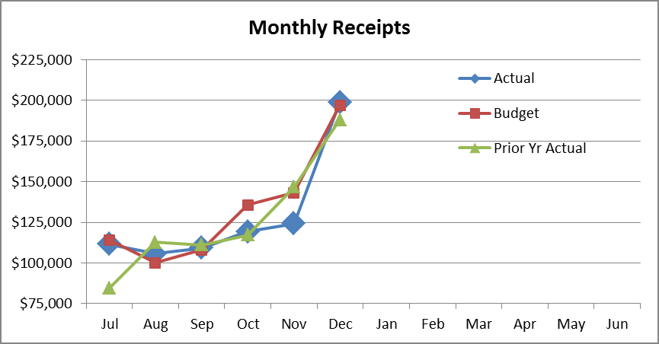

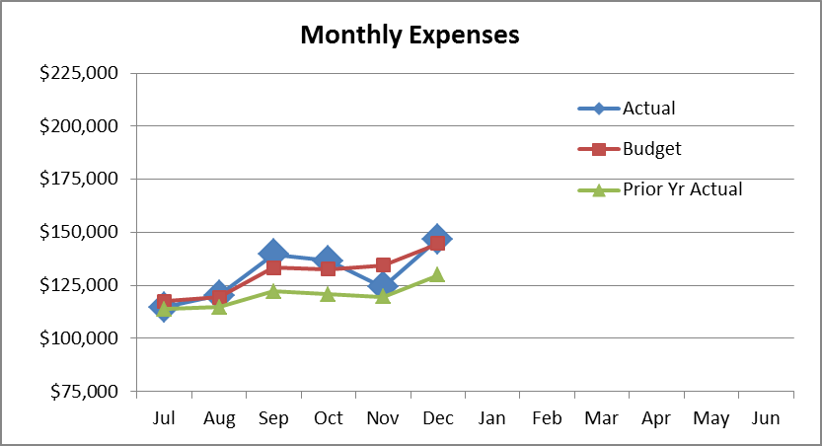

$70,000
Cumulative YTD Receipts Over/Under Expenses

$50,000

Mar Apr May Jun

$30,000

Actual

$10,000

Budget

-$10,000

-$30,000

-$50,000

-$70,000

Jul Aug Sep Oct Nov Dec Jan Feb

Prior Yr Actual

Adult Ed Meeting January 10, 2017

+The Stewardship Committee will host 4 sessions of the 10:10 hour in the lounge beginning Jan 22 through Feb 5th. The theme for these 4 weeks is titled, "More than Money Matters."

+February's 10:10 hour for 4 weeks in room #40 will be presented by Rev. Mark Grandquist, a professor at the Seminary speaking on The History of the Lutheran Church in America.

+The committee that was formed related to racial issues within our surrounding communities is called "My Neighbor and Me." This committee is planning to present 3 identical sessions each week for a 3-week period of time. These sessions are called reading circles. The sessions each week will meet on Monday and Wednesday evening and on Friday morning, The first sessions will begin the first week in February.

Following these three -week sessions, they are hosting a half-day retreat on March 4 and have invited Rev. Dr. Karen McKinney from Bethel University as the guest speaker. There is a book titled, A Good Time for the Truth, edited by Sun Yung Shin, that the committee recommends, but it is not required reading. The Adult Ed Committee is providing financial support for the retreat.

After the retreat, the reading circles will resume at the same times for another three weeks.

+Adult Ed is busy planning participation in the 75th Anniversary of RLC together with the 75th Anniversary Committee. Mary Erickson, Adult Ed Chair, is part of that committee.

+Adult Ed is working on the 2017-2018 Schedule.

